Title in Arial Bold, 16 pt, line spacing 21 pt, justified (centered), 8 pt space after
Ron Smith ¹, Anne Brown ³ and Jane Doe ³
¹Department of Serendipitous Research, Lund University, Lund, Sweden
²Science Institute, Umeå, Sweden
³Faculty of Behavior Studies, Karolinska Institute, Stockholm Sweden
Times New Roman Italic, size 11 pt on 15 pt, centered.
Replace dummy text/names/figures/tables with your own text/names/figures/tables.

Abstract (Arial 12 pt bold italic)
The abstract goes here. Maximum of 200 words. Times New Roman Italics, size 11 pt, margin adjusted.

This template is likely to work properly in MS Word for Windows and Mac. A simple way of using it consists in substituting own text for this one. The format of this passage is to be used in the main body of the paper after headings and at the top of columns.
The text is written in Times New Roman, size 11 points. The paper margins are 20 mm on all sides. Column width is 81.4 mm with 7 mm between the columns. The text is both right and left justified.

Header 1 (Arial 12 pt bold)

Then the text begins again. References should appear with names and year within parentheses (Fant, 1960) or Fant (1960) or Fant (1960:34). Please note that page numbers should be given whenever a specific piece of information is given, and not the entire work.
Please note that references should be given in dark blue, according to modern typographical practice (see examples above).
The first line of each new passage within a section is indented by 4 mm, as in this example.

Header 2 (Arial 11 pt bold italic)

The sub-subsection heading is the lowest level heading permitted in the document (New passage).
For phonetic symbols and text that includes non-Latin1 letters, use of Gentium is recommended; see
http://www.ling.su.se/fon/IPA-tecken.htm
... where you can also find a tool that facilitates the use of phonetic symbols. For phonetic symbols in headings, use Arial Unicode MS (this may require readjustments).
Alternatively, use an IPA Character picker.

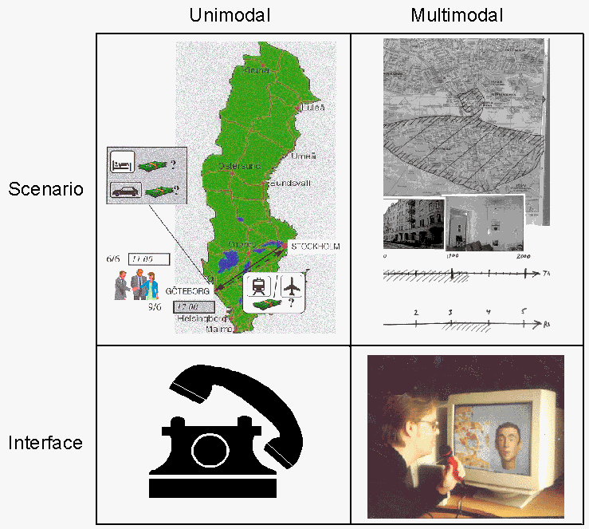
Figure 1. A figure caption is placed below the figure using Times New Roman Italics, size 10 pt, margin justified, 6 pt space before.

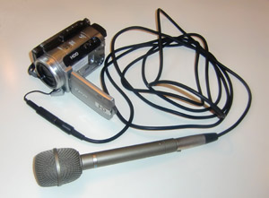
Plate 1. A plate caption is placed below the figure using Times New Roman Italics, size 10 pt, margin justified, 6 pt space before.
Text text text text text text text text text text text text text text text text text text text text…
Table 1. Table headings are always written above the table, whereas captions to figures/plates/photos are written below the figures. Text is written in Times New Roman Italics, size 10 pt with a 6 pt space before.

 | Var 1 | Var 2
No. subjects | 16 | 16
No. something | 602 | 847
No. something else | 413 | 799
No. something else again | 4,013 | 5,829
Percentages | 41.8% | 34.3%
Other percentages | 61.0% | 36.4%

Text text text text text text text text text text text text text text text text text text text text…

Header 1 (Arial 12 pt bold)
The final version of your paper, whose length must not exceed four (4) pages, should be submitted electronically in both pdf-format and doc/docx formats (for editing) se no later than DATE 2017.
Text text text text text text text text text text text text text text text text text text text text text text text text text text text text text text text text text text text text text text text text text text text text text text text text text text text text text text text text text text text text text text text text text text text text text text text text text text text text text text text text
Text text text text text text text text text text text text text text text text text text text text text text text text text text text text text text text text text text text text text…

Table 2. Table headings are always written above the table, whereas captions to figures/plates/photos are written below the figures. Text is written in Times New Roman Italics, size 10 pt with a 6 pt space before. EXAMPLE OF TABLE SPANNING TWO COLUMNS, IF DESIRED (IF NOT: DELETE)
 | Variable 1 |  | Variable 2 |  | Variable 3 |  | Variable 4
Phonation type | Ingressive | Egressive | Ingressive | Egressive | Ingressive | Egressive | Ingressive | Egressive
No. phases analysed | 69 | 70 | 8 | 8 | 29 | 29 | 109 | 107
Mean duration (ms) | 2014 | 2774 | 1537 | 2000 | 2426 | 2120 | 1819 | 1401
Mean duration egr+ingr (ms) | 2397 |  | 1768 |  | 2273 |  | 1612
Standard deviation | 309.3 | 515.7 | 518.8 | 588.1 | 300.5 | 193.9 | 254.1 | 163.5
Maximal duration | 2800 | 3700 | 2600 | 2850 | 3200 | 2500 | 3320 | 1830
Minimal duration | 1300 | 1200 | 900 | 900 | 2000 | 1700 | 940 | 670
Δ t test (paired-samples, two-tailed) | p < 0.001 |  | p = 0.011 |  | p < 0.001 |  | p < 0.001
Δ Wilcoxon (two related samples) | p < 0.001 |  | p = 0.027 |  | p < 0.001 |  | p < 0.001

Header 1 (Arial 12 pt bold)
Text text text text text text text text text text text text text text text text text text text text text text text text text text text text text text text text text text text text text text text text text text text text text text text text text text text text text text text text text text text text text text text text text text text text text text text text text text text text text text text text text text text text text text text text text text text text text text text text.
Text text text text text text text text text text text text text text text text text text text text text text text text text text text text text text text text text text text text text.
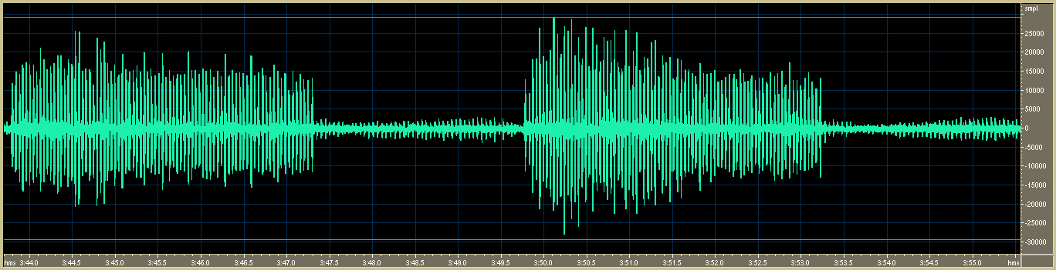
Figure 2. Figures and plates can also stretch across the entire page. IF NOT DESIRED: DELETE.

Text text text text text text text text text text text text text text text text text text text text text text text text text text text text text text text text text text text text text text text text
Text text text text text text text text text text text text text text text text text text text text text text text text text text text text text text text text text text text text text text text text
Text text text text text text text text text text text text text text text text text text text text text text text text text text text text text text text text text text text text text…

Acknowledgements (Arial 12 pt bold)
Text text text text text text text text text text text text text text text text text text text text text text text text text text text text text text text text text text text text text text text text
Text text text text text text text text text text text text text text text text text text text text text text text text text text text text text text text text text text text text text text text text
Text text text text text text text text text text text text text text text text text text text text text text text text text text text text text text text…

Notes (Arial 12 pt bold)

Footnotes (at the bottom of a page) are not to be used; only Endnotes are allowed, and these are to be used sparingly. Indicate endnotes in the text with a superscript number.

References (Arial 12 pt bold)
References are justified, Times New Roman 10 pt with a 4 mm hanging indent. Please note from the samples below how author names (one or several), years, and volume, issue/number and pages numbers are written.
The References should be listed alphabetically.
References follow JIPA style (similar to Chicago), with the first author name given as Surname, Firstname and the following author(s) as Firstname Surname.
No parentheses should be used for year of publication. Volumes, issues/parts and page numbers should be written as shown in the examples below.
If there are several works by the same author(s), please put the most recent first, and the rest in falling order.
Please also note that page numbers are separated by an n dash (–), not a hyphen (-).

Bagemihl. 1988. The Morphology and Phonology of Katajjait (Inuit Throat Games). Canadian Journal of Linguistics 33(1):1–58.
Deacon, T. 1997. The symbolic species: The co-evolution of language and the human brain. London: Allen Lane & The Penguin Press.
Dieth, E. 1950. Vademecum der Phonetik. Bern: A. Francke AG. Verlag.
Edwards, J. A. 2001 The transcription of discourse. In D. Schiffrin, Deborah Tannen & Heidi E. Hamilton (eds.), The handbook of discourse analysis, Malden, MA: Blackwell, 321–348.
Ertmer, D. J., N. M. Young & S. Nathani. 2007. Profiles of vocal development in young cochlear implant recipients. Journal of Speech, Language, and Hearing Research 50:393–407.
Gavriely, N, Y. Palti, G. Alroy & J. B. Grotberg. 1984. Measurement and theory of wheezing breath sounds. Journal of Applied Physiology 57(2):481−492.
Grønnum, N. 1998. Fonetik og Fonologi. Almen og Dansk. Copenhagen: Akademisk Forlag.

Additional instructions

Please make sure that your submitted paper is not more than four pages, including References.

Please avoid double spaces, and orphans like: p. 1.

To avoid orphans: use non-breaking spaces: p. 1.

