Next, Previous, Stop: Implementing an Audio Metaphor of Tape Recorder Buttons for the THISL Information Retrieval Engine Speech Interface

James N. Carmichael
Speech and Hearing Research Group
Dept. of Computer Science
University of Sheffield
Regent Court, 211 Portobello St.
Sheffield, S1 4DP,
United Kingdom.
e-mail: natty@dcs.shef.ac.uk
or scifibaje@yahoo.com
(44) 0114-222-1810 (Dept. main office)
07950-208091 (Mobile)

Abstract
This proposal discusses the implementation and preliminary usability study results of a speech user interface (SUI) for the Thematic Indexing of Spoken Language (THISL) Spoken Document Retrieval (SDR) system. The SUI – dubbed THISLSpeak – has been designed for integration into a multi-modal interface but has the potential to function in stand-alone mode (as would be necessary if queries were conducted via telephone). The objective is to increase the efficiency of task performance by implementing speech commands which would emulate the functions of the Next (>¦), Previous (¦<) and Stop () iconic buttons that are typical of tape recorder-type software applications. The user is informed – via various combinations of audio-visual prompts in its multimodal manifestation – about the system’s state and available options. This application, developed using the IBM implementation of the Java Speech Application Programming Interface (JSAPI), is restricted to those systems which already have the IBM Via Voice speech recognition and synthesis engine installed.

1. Background Information: The THISL Information Retrieval Engine
The creation of an information retrieval (IR) engine for the retrieval of radio news broadcast spoken documents was one of the products of the THISL project, a component of the European Commission’s ESPRIT programme. The THISL IR engine is queried in a similar fashion to the popular internet text-based search engines such as Google or Altavista. A typical session is represented by the following use case diagram:

Figure 1 :Use Case Scenario for THISLSPEAK (Multimodal Format)
Select News Source(s) for Query
Dictate/Type Query
Select Start and End Date of Search Query
Select a Document from Set of Returned documents
Listen to Selected Document

2. Design and Implementation Issues: “What did you say?”
The most challenging design problem in developing THISLSpeak related to the processing of Out Of Vocabulary (OOV) items. In the context of indexing and retrieval of broadcast news, OOV terms constitute a significant obstacle for automatic speech recognition (ASR) at the level of both news transcription and query capture. The following screen shot showing the results of a user’s query – “When did Suharto leave?” – dramatically illustrates the shortcomings of even the sturdiest speaker-independent ASR systems.

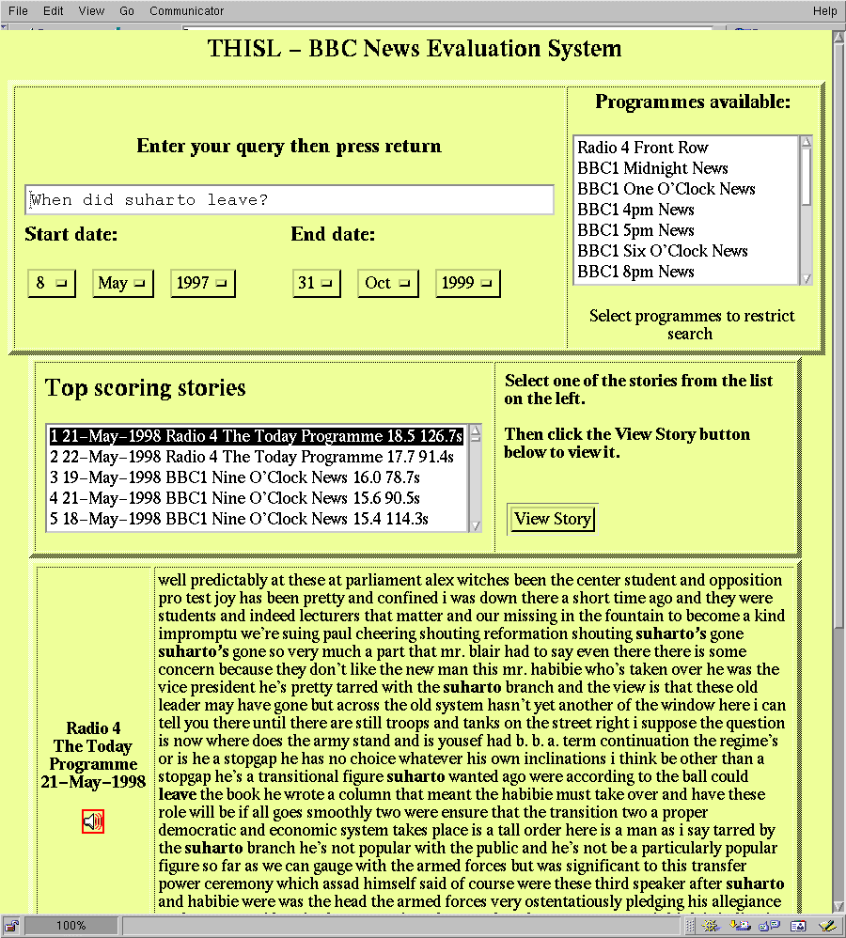
Figure 2: Screenshot of Non-SUI THISL’s Graphical User Interface

Although the audio for the retrieved spoken document is perfectly understandable, the first three lines of the ASR-generated transcript -- “parliament alex witches...we’re suing paul cheering...” -- contain enough errors as to significantly obscure meaning. For this session, the key search words have been correctly recognised by the ASR software, however there have been instances where misrecognition of key phrases has resulted in relevant documents not being retrieved. It is not within the scope of this study, however, to address these ‘back end’ issues; they are mentioned merely to provide a better understanding of the difficulties involved in designing a speech interface robust enough to capture a possibly large quantity of OOV items featured in spoken queries originating from a large heterogeneous corpus of users.

2.1 Transition between System States: Word-Spotting vs. Dictation modes
When launched in multimodal configuration, THISLSpeak audio-visually informs the user (via text to speech synthesis and on-screen messages) of the initial system state and available options. The user is prompted to produce a spoken query which is repeated for verification both orally and on-screen, after which a series of selections is solicited – such as setting the start and end dates for the search, selecting which archives are to be queried, etc – before the spoken query is converted into a text string and submitted to the IR engine. The user is then orally informed when the engine returns a set of documents.

The following transcript represents a typical THISLSpeak session (key words for recognition / rule grammar transition in word spotting are underlined):-
THISLSpeak: THISTLE-SPEAK is listening. Please wait until you see the screen appear. After you see the screen, you have three options. You may turn off speech, dictate your query or exit the program. Read the message that will now appear. [On-screen message appears in multimodal format]
User: I would like to dictate a query.
THISLSpeak: ThislSpeak is listening, please speak very slowly and carefully.
User: When was the last time the New England Patriots won the Super Bowl?
THISLSpeak: “When was the last time New England paid riots one superb bowl.” Is that correct?
User: No! That’s total rubbish!
THISLSpeak: Sorry, repeat please.
User: I said, [probably more slowly and pronouncing words distinctly]“When was the last time the New England Patriots won the Super Bowl?”
THISLSpeak: “I said when was the last time the New England paid riots one the super bowl” Is that correct?
User: No, I didn’t say anything about paid riots…
THISLSpeak: I’m sorry, please spell the first word I got wrong. Say “stop” after you have finished spelling the word.
User: P-A-T-R-I-O-T-S, stop.
THISLSpeak: P-A-T-R-I-O-T-S is “Patriots”, is that correct?
User: Yes.
THISLSpeak: Thank you. Any other words I got wrong?
User: No, I don’t think so…
THISLSpeak: Your query is “When was the last time the new England patriots one the super bowl?” Is that correct?
User: Yeah, that’s it…
THISLSpeak: Would you like to query all news services available or just some of them?
User: I think I’ll query all.
THISLSpeak: How far back would you like to search? From what date to what date? If it does not matter, please say not important, otherwise please give me the start date for your search now, please
User: The dates are not important.
THISLSpeak: Ok, would you like to submit your query?
User: Yeah, do that.
THISLSpeak: Query being submitted, this may take a few minutes, please hold… [after THISL IR engine has returned the results] …97 news clips have been returned. Do you want to hear the highest scoring ones, the most recent ones or those from a particular news program like the BBC 1 Six o’clock News? Say “repeat” to hear this message again.
User: Er…give me the latest stories
THISLSpeak: The first one comes from BBC Six o’clock News on February third, please say stop at any time to stop playback of news clip or next to move on to the next one. Remember to say finish to end all playback…[ playback of news clip starts]
User: Stop, [playback is interrupted] next…
THISLSpeak: [next news clip starts]
User: Finish.
THISLSpeak: [news clip playback stop] Do you want to make another query?
User: No, that’s it for now.
THISLSpeak: Thank you for using THISLSpeak. Goodbye. [application terminates]

Except when executing query capture, the application operates in word-spotting mode supported by appropriate rule grammars. This heavy reliance on restrictive parameters for user input was implemented to increase recognition accuracy. When in dictation mode (i.e. during the capture/processing of a spoken query), the user is encouraged to make his queries as concise as possible if the application is obliged to enter spelling mode in order to cope with OOV item(s). THISLSpeak’s rule grammar transition is generally cyclic: it is presumed that users will generally use this application to make repeated queries during a single session. The application is therefore designed to re-set itself (by re-entering it’s initial three-option default mode after successful completion of a query) for an indefinite number of iterations.

3. Successes and Failures: “Say that All Again?”
The most challenging (and as yet, not satisfactorily solved) problem is that of communicating statistical data associated with the returned spoken documents. In most instances, the user (after getting over the initial novelty of querying a spoken document archive) neither has the time nor inclination to listen to all of the returned documents and preliminary findings suggest that the implementation of default filter parameters – based on various document attributes such as date, length, relevancy score, etc. – create more manageable subsets of around 10-15 documents which greatly assist in locating the new clip(s) containing the desired information. This information filtering was supported by the provision of tape recorder audio metaphors – “Next”, “Previous”, “Stop” and “Replay” – which allowed the user to skim through documents by performing the audio equivalent of visually scanning the first few lines of a news document, then opening the next one and repeating this process until the best match is encountered.

Although theoretically appealing, the abovementioned technique did not live up to expectations due to certain technical reasons:

- The inordinate amount of lag time between the issuing of a speech command and the response: users complained that the application did not interrupt playback / restart playback of a spoken document quickly enough when ordered to do so.
- Word-spotting mode at best restricted natural dialogue and at worse could derail the session: if the user chose to say “Alright” instead of “Yes”, nothing happened and the poor user was left clueless in terms of how to proceed
- Listening to on-line audio help can be tedious and often the information is not retained even when repeated. It was observed that audio messages exceeding 15 words and conveying more than two instructions generally confused the user.

Project duration: Feb. 1st, 1997 to Jan. 31, 2000.
The ESPRIT Information Technologies programme is itself part of the larger Fourth Framework Programme.
Note that although there is an instance of misrecognition (‘one’ as opposed to ‘won’), it will not greatly affect the IR engine’s search in this particular instance.
The default word spotting mode recognises three commands “Dictate”, “Turn off [speech capability]” and “Exit [terminate program]”

