Master Theses
  - 30 credits – e-FACTORY Efficient Automation for Customized products in Swedish Industry
TL; DR
There’s a demand to implement state-of-the-art machine learning in close collaboration with the division of machine design and industry partners. Apply if you want to know more and get the chance to do something great.
Background:
The industrial trend is currently to increase product customization, and at the same time decrease cost, manufacturing errors, and time to delivery. These are however all conflicting goals. To stay competitive LiU has initiated the project e-FACTORY to develop a digital framework that integrates digitalization technologies to stay ahead of the competitors. One main issue with today’s processes are the estimates the sales staff needs to make when it comes to both product and production development. The cost is too high to involve product and production engineers in each quote.
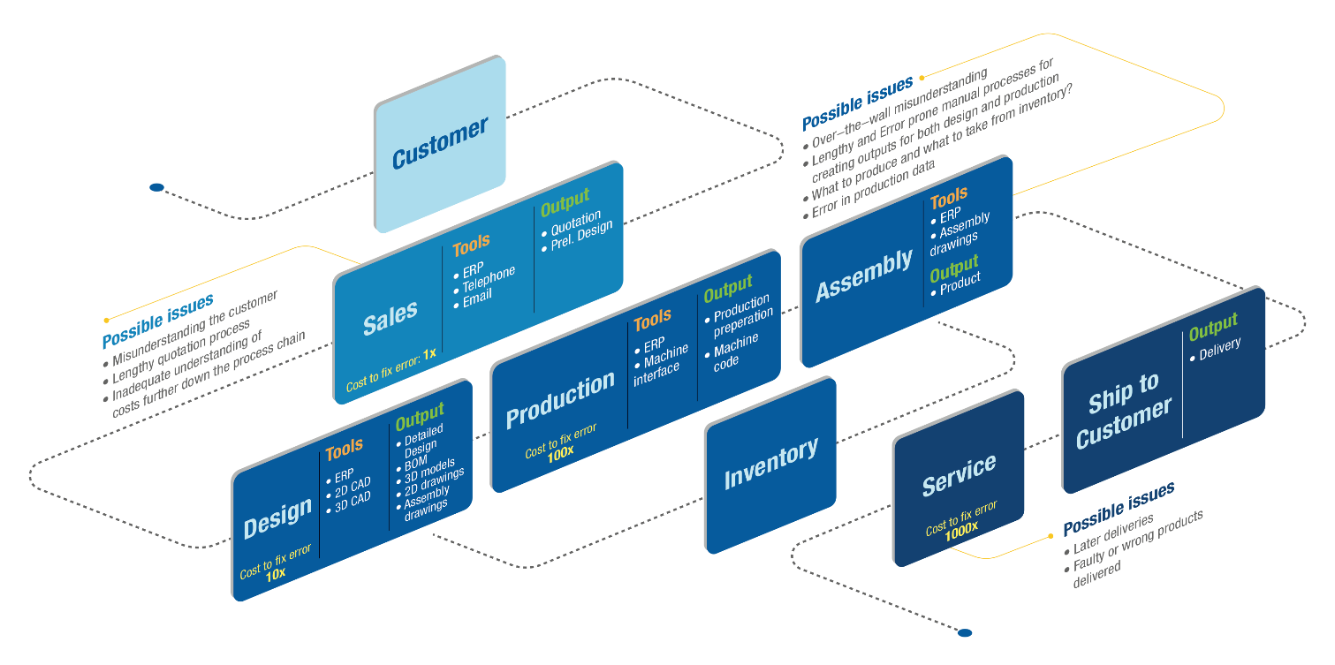
The scope of the project is to increase product and production development effectiveness for manufacturing companies by employing state-of-the-art automation technologies. e- FACTORY will help companies to obtain a more efficient and integrated product configuration and production planning process, starting already at the sales stage.
Target:
The purpose of the theses is to investigate the feasibility of using enabling machine learning algorithms. Subjects for this thesis is
- Achieve real time data extraction regarding customer preferences by using Augmented Reality, e.g. automatically generating 3D geometries in customer’s smart phones. An example could be to recognize and extract specific features on walls which can later be used to configure windows and such.
- Train an appropriate machine learning algorithm that can recognize and extract specific features.
- Compare the predictions of the machine learning algorithm with the manually created materials and obtain the accuracy
- Suggest ways to improve model accuracy

Assignment:
The work will be done from Linköpings University, but in close relation with several industrial partners. Necessary literature studies on relevant methods and techniques might be warranted. An algorithm, tool or method will be developed depending on agreement with the supervisor. The results of the project will be presented both in written report and oral presentation.
Education:
Master of Science or equivalent
Start date: As agreed
Estimated time needed: 20 weeks
Contact person:
Mehdi Tarkian; mehdi.tarkian@liu.se
NOTE:
High response rate might result in more thesis proposals being proposed.

