Deep learning for Detection of pain pattern in the electrophoresis microscopy images
Background:
Two-dimensional gel electrophoresis (2D-GE) is a technique used to detect and quantify different proteins obtained in a sample from body fluids (e.g. plasma). The proteins are organized depending on their properties and an image is taken using a microscope. The 2D-GE image below shows the concentrations of different proteins, which can be analyzed to detect relationships of protein distribution in the sample. In this thesis, a set of 2D-GE images is provided containing samples obtained from both healthy subjects and patients experiencing pain. The aim is to implement and evaluate deep learning models to classify the images to find patterns or biomarkers related to pain in the protein distributions. A preliminary feasibility study is performed with very positive results therefore this thesis will focus on improving the results. Not much scientific literature is available on the 2D-GE images why this project has interesting aspects to explore on non-classical medical images.
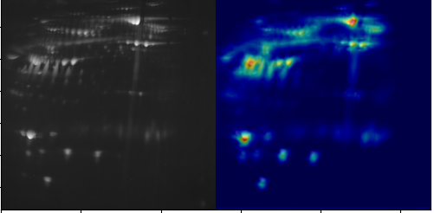
Original 2D gel image of plasma containing pain biomarkers and the attention map

Data: 2D gel microscopy images from ca 280 samples which include multiple classes of pain biomarkers. It is possible to only work on the binary classification task for pain detection or on multiple classes.
Reference: Hayashi, N. et al. Diagnosis of Sepsis by AI-Aided Proteomics Using 2D Electrophoresis Images of Patient Serum Incorporating Transfer Learning for Deep Neural Networks. Appl. Sci. 2021, 11, 1967. https://doi.org/10.3390/app11041967.
Research objectives:
1- Review of the available literature on relevant state-of-art research and methodology
2-Plan for the steps of analysis including any necessary preprocessing (e.g. image augmentation and normalization), data imbalance and splitting into train and test sets.
4- Implement at least two models for the classification of images into pain and no pain.
5- Perform training and evaluation using different strategies (e.g. scratch-training, transfer learning).
6- Compare the performance of the different methods using solid statistical tests.
7- Suggest a suitable visual explainable AI (e.g. gradCAMs or occlusion maps) and implement it on the used models.
8- Write a report and prepare a presentation
Please note that the tasks are subject to change depending on the results obtained during the workflow. A computer with a 6 core CPU, 64 GB RAM and 2 × Nvidia RTX 2080 Ti GPU is available.
Required background:
Interest in medical questions, solid knowledge of Python deep learning (PyTorch or TensorFlow)

Contact person: Neda Haj-Hosseini
Department of Biomedical Engineering (neda.haj.hosseini@liu.se)

