Improving brain tumor segmentation using transformer-based segmentation networks

The BraTS 2021 dataset contains MRI volumes and tumor annotations from 1251 tumor patients, see an example below. The image patches show from left to right: the whole tumor (yellow) visible in T2-FLAIR (Fig.A), the tumor core (red) visible in T2 (Fig.B), the enhancing tumor structures (light blue) visible in T1Gd, surrounding the cystic/necrotic components of the core (green) (Fig. C). The segmentations are combined to generate the final labels of the tumor sub-regions (Fig.D): edema (yellow), non-enhancing solid core (red), necrotic/cystic core (green), enhancing core (blue).
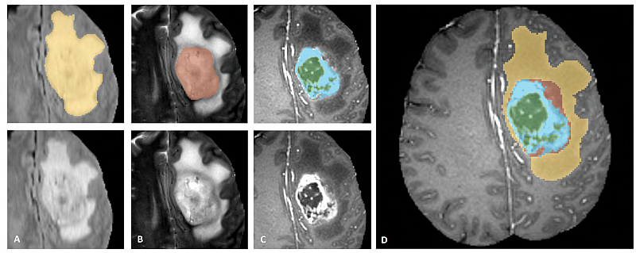
Using deep learning, it is possible to train a segmentation network to perform segmentation of the different parts of the tumor. Traditionally, CNN-based segmentation networks like the U-Net have been very popular. Recently, vision transformers have outperformed CNNs for several tasks. In this master thesis, the main goal is to investigate if
transformer-based segmentation networks perform better than CNNs. A computer with a 6 core CPU, 64 GB RAM and 2 x Nvidia RTX 2080 Ti graphics cards is available for the project.

The following questions are of interest

Are transformer-based segmentation networks significantly better than CNNs for brain tumor segmentation?

How much data is required to obtain reasonable performance, when using transformer networks and CNNs?

Is there a significant benefit of using 3D transformer-based networks, compared to 2D networks?

Requirements: Python programming, Deep learning.

Contact person: anders.eklund@liu.se

