Pathology diagnosis using deep learning methods
Background:
Histology images are commonly used for disease diagnosis. However, examination of the images is an expert task that can be facilitated and made more accurate by implementing automatic methods. In this master thesis, a set of approximately 12000 histology images from about 100 tissue samples will be provided where diagnosis should be placed using appropriate deep learning methods. An example of brain tumor histology image is given in the figure below. This thesis is a continuation of an earlier project with successful results in which we aim to improve the performance and the statistical evaluation of the previous work by using a much larger dataset and deep learning parameters.
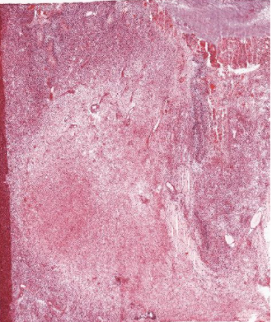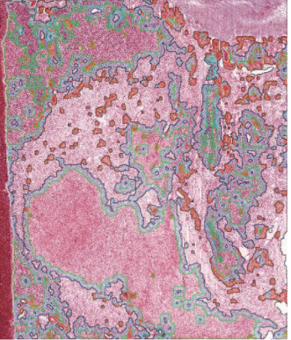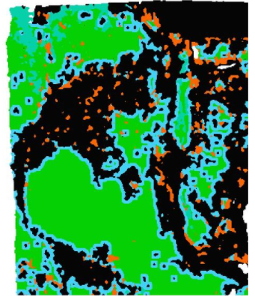
H&E
H&E with feature borders
Feature annotations
Ref: IvyGap Atlas
Data:
- ~12000 Histopathology images (H&E stained) from brain tumor
Objectives:
- Review of the available literature and analysis methods
- Preprocessing the large images (e.g. 15040 × 18080 pixels) to extract training patches of for example 224 × 224 pixels (and a tumor label of each patch)
- Consider data imbalance and data leakage in the train and test set using suitable statistical measures that consider data imbalance
- Implement VGG16 and a model of your choice to train a 2D CNN that classifies patches
- Does a 2D CNN pre-trained on histology images (TCGA) perform significantly better compared to a 2D CNN trained from scratch? A comparison will be done using a non-parametric significant test.

Choose one of the below:
- Investigate methods for patch level classification uncertainty estimation by implementing statistical measures for evaluation of these methods
- Investigate methods for explaining patch level classification by implementing XAI and statistical measures
Please note that the tasks are subject to change depending on the results obtained during the workflow. A computer with a 6 core CPU, 64 GB RAM and 2 × Nvidia RTX 2080 Ti graphics cards is available for the project.

Required background:
Interest in medical images, Python programming, Deep learning.
Contact person: anders.eklund@liu.se
Additional supervisor / customer: Neda Haj-Hosseini, Iulian Emil Tampu
Department: Biomedical Engineering (IMT), LiTH, US Campus

