Classifying femur fractures using vision transformers

Background

Drugs commonly used in the treatment of osteoporosis (bisphosphonates) inhibit cell function of one specific cell type in bone, leading to increased bone mass and reduced fracture risk. This treatment has been used successfully for decades. Long-term inhibition of these bone-specific cells has recently been shown to cause bone material insufficiency, leading to spontaneous stress fractures in the thigh bone – Atypical Femoral Fractures (AFF). These fractures show features on x-ray images that differentiate them from Normal Femur Fractures (NFF). However, these features are very subtle and can easily be overlooked if not specifically sought for (Figure 1). The detection rate of AFF on clinical plain radiographs is <7%, and reports of drug adverse reactions to the Swedish Drug Agency have an even lower detection rate. While these events are rare compared to fractures that can be prevented, they are of clinical concern and have resulted in decreased use of these medications. As these events are so rare, standard statistical models have failed to identify reliable risk factors that would allow a precision medicine approach to identifying which patients to treat and for how long.

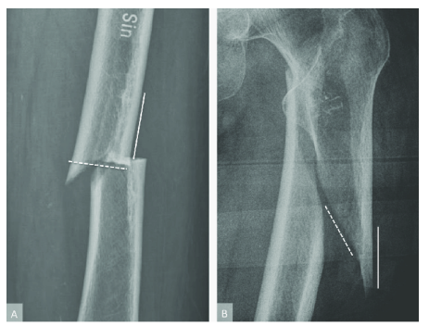

Figure 1. Atypical femur fractures (AFF, image A) and normal femur fractures (NFF, image B).

Traditionally, CNNs have been the most common architecture for classifying images. Recently, vision transformers have outperformed CNNs for several tasks.

Objectives

Implement 2D CNNs and vision transformers for classification of AFF and NFF, are vision transformers significantly better at classification compared to CNNs? Are vision transformers more computationally demanding?

Do CNNs and vision transformers use different areas of an image to make the decision?

For 2D CNNs there are several networks pre-trained on ImageNet. Do vision transformers pre-trained on ImageNet perform better than CNNs performed on ImageNet?

Data

About 4300 X-ray images from some 1200 patients, of which about 20% are AFF.

Required background

Machine learning, deep learning, Python programming

Computing resources

The student will have access to very good computing resources (graphics cards) for deep learning.

Contact persons

Anders Eklund, anders.eklund@liu.se, Department of Biomedical Engineering, Department of Computer and Information Science, Center for Medical Image Science and Visualization

Jörg Schilcher, jorg.schilcher@liu.se, Department of Orthopaedic Surgery, University Hospital Linköping

