Impact of improved wastewater treatment on the concentration of total nitrogen in the Stockholm archipelago

Claudia Libiseller, Anders Grimvall and Mohamed Hussian

Dept. of Mathematics, Div. of Statistics, Linköpings universitet, SE-58183 Linköping, Sweden

Report prepared for the Swedish Environmental Protection Agency

Draft version

2005-08-04
Abstract

Nitrogen removal from wastewater in the municipality of Stockholm was substantially improved in the mid 1990s, and the total emissions from the treatment plants were then decreased about 50%. We examined how this influenced the concentration of total nitrogen in receiving waters in the Stockholm archipelago. Because of the complex hydrography in the study area and the large variation in the source regions of the sampled waters, we focused on establishing overall temporal trends in nitrogen along salinity gradients. Our investigation showed that, for each season, most of the variation in the nitrogen data collected during the time period 1989-2004 could be described by a simple decreasing function of time (year) and salinity. When the study area was divided into the inner and outer archipelago the goodness-of-fit of this model was even better. The downward trend in nitrogen was found to be very pronounced in the inner archipelago. In the outer archipelago there was also a downward trend, whereas no trend could be discerned at a reference site in the open sea. Furthermore, the detected trends in the inner archipelago coincided in time with the major improvements in wastewater treatment. Formal statistical tests for trends at individual stations provided additional support for the detected trends.

Introduction
Nitrogen removal from wastewater in the municipality of Stockholm was substantially improved in the mid 1990s, and the total emissions from the treatment plants were then decreased about 50%. Simple summaries of water quality data from receiving waters showed that the cited measures strongly influenced the concentration of total nitrogen in the inner part of the Stockholm archipelago, whereas the impact on the outer archipelago was less obvious. Because of the large investments that had been made in wastewater treatment, this called for a more thorough evaluation of water quality trends.

Trend assessments in coastal areas and archipelagos is often a difficult task. The randomness in the mixing of saline and fresh waters can long conceal important anthropogenic trends or create spurious trends. Furthermore, the complex hydrography that characterize many such areas can make process-based modelling impracticable. Hence, we decided to use a statistical approach in which salinity was treated as a covariate. In a relatively recent study of water quality trends at a sampling site in the Baltic sea, Libiseller and Nordgaard (2003) divided the data sets into several univariate time series representing different salinity levels, and then tested them separately for trend. Here, we modelled the total nitrogen concentration as a season-specific monotonic function of both salinity and time (year). In addition, the presence of trends was assessed by employing a non-parametric Mann-Kendall test that can accommodate covariates (Libiseller & Grimvall, 2002).

Data
Water quality data for the Stockholm archipelago were obtained from StockholmVatten AB. A map showing all monitoring stations can be seen in Figure 1. For the present study we used all stations that had a monitoring program was commenced in 1989 or earlier. This made 24 stations available for assessment, 13 of which are situated in the inner archipelago and 11 in the outer archipelago. The analysis was made for the time period 1989-2004 and all stations included had monitoring programs over the entire time period. Stations having the name 'xx -veckostation' were measured weekly, whereas all other stations had monthly or more infrequent monitoring. Generally there were relatively few samples taken during the winter months (Nov-Mar).

For comparison we also included a reference site, the Baltic Sea station Landsort (BY31). For this site, observations at a depth of 0 – 30 m were selected to represent changes above the halocline. Observations were available for the years 1989 – 2003. However, during the first years, measurements were made less than once a month.

For a summary of all stations included, see Table 1. All nitrogen concentrations are expressed in μg N/L, and the salinity values are given in psu.

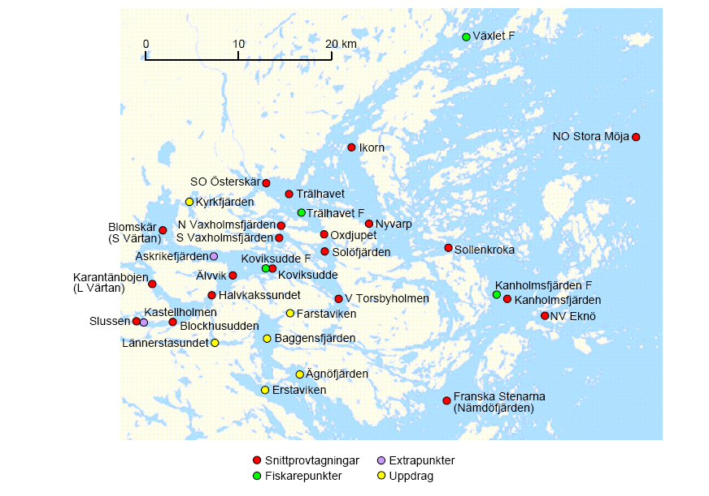
Figure 1: Map of monitoring stations in the Stockholm archipelago (Skärgårdsrapporten 2005).

Table 1a: Investigated monitoring sites in the inner archipelago.
 | Time period | Depth (m)
Älvvik | 1989 – 2004 | 0 – 40
Blockhusudden | 1989 – 2004 | 0 – 36
Blomskär | 1989 – 2004 | 0 – 27
Ekhagen | 1989 – 2004 | 0 – 21
Halvkakssundet | 1989 – 2004 | 0 – 50
Karantänbojen | 1989 – 2004 | 0 – 20
Koviksudde | 1989 – 2004 | 0 – 36
Koviksudde – veckostation | 1989 – 2004 | 0
Norra Vaxholmsfjärden | 1989 – 2004 | 0 – 24
Slussen | 1989 – 2004 | 0 – 26
Södra Vaxholmsfjärden | 1989 – 2004 | 0 – 24
Solöfjärden | 1989 – 2004 | 0 – 44
V Torsbyholmen | 1989 – 2004 | 0 – 24
Table 1b: Investigated monitoring sites in the outer archipelago.

 | Time period | Depth (m)
Åkerviksudde - veckostation | 1989 – 2004 | 0
Franska Stenarna | 1989 – 2004 | 0 – 70
Ikorn | 1989 – 2004 | 0 – 45
Kanholmsfjärden | 1989 – 2004 | 0 – 100
NV Eknö | 1989 – 2004 | 0 – 50
Nyvarp | 1989 – 2004 | 0 – 55
SO Österskär | 1989 – 2004 | 0 – 20
Sollenkroka | 1989 – 2004 | 0 – 40
Trälhavet II | 1989 – 2004 | 0 – 55
Trälhavet – veckostation | 1989 – 2004 | 0
Växlet – veckostation | 1989 – 2004 | 0

Table 1c: Reference site in the Baltic Sea.

 | Time period | Depth (m)
Landsort (BY31) | 1989 – 2003 | 0 – 30

The quality of the collected data has been thoroughly assessed by StockholmVatten AB throughout the study period 1989-2004. Moreover, all potential problems in the sampling or chemical analyses have been coded and commented in the database. For the chemical parameters analysed in this report, a number of observations were missing due to incorrect transport or analysis. Some other observations that were flagged 'late analysis' or 'unsecure value' were kept in the data set, because all such values looked reasonable. Missing values and coded observations were distributed evenly over the entire monitoring period and over a number of stations. Hence, it was considered very unlikely that the cited deficiencies would influence the final results of the trend assessment.

Exploratory analysis
Wastewater treatment was substantially improved during the 1990s to enable a more efficient removal of nitrogen. Figure 2 illustrates the discharge of total nitrogen from four wastewater treatment plants in the Stockholm area. As can be seen, a considerable drop in total nitrogen started around 1996, and the present levels are only about 50% of the levels that prevailed in the early 1990s.

To get a quick overview over water quality changes in receiving waters, six monitoring stations were selected to represent different distances from the area of emission. Box-and-Whisker plots (Figures 3 - 8) show temporal trends for total nitrogen and salinity in the the Stockholm archipelago and the Baltic Sea. The selected stations were: Slussen (in Stockholm City), Blockhusudden and Solöfjärden (inner archipelago), Sollenkroka and NV Eknö (outer archipelago) and Landsort (reference site, the Baltic Sea).

Figure 2: Total Nitrogen emissions from wastewater treatment plants in Stockholm.

Figure 3: Total nitrogen (left) and salinity (right) at the monitoring station Slussen in central Stockholm.
Figure 4: Total nitrogen (left) and salinity (right) at the monitoring station Blockhusudden in the inner Stockholm archipelago.

Figure 5: Total nitrogen (left) and salinity (right) at the monitoring station Solöfjärden in the inner Stockholm archipelago.
Figure 6: Total nitrogen (left) and salinity (right) at the monitoring station Sollenkroka in the outer Stockholm archipelago.

Figure 7: Total nitrogen (left) and salinity (right) at the monitoring station NV Eknö in the outer Stockholm archipelago.
Figure 8: Total nitrogen (left) and salinity (right) at the monitoring station Landsort in the Baltic Sea.

Response Surfaces
Since total nitrogen levels in receiving waters are strongly influenced by the mixing of water from different source regions (fresh water and saline sea water), we analysed the data using a method that can simultaneously visualise temporal trends and the dependence structure between salinity and total nitrogen. To be more precise, we used a response surface methodology (Hussian et al., 2004, Burdakov et al, 2005). This method assumes that the included variables have a monotonic (decreasing or increasing) relationship. In our case, total nitrogen typically increases as salinity levels become smaller, since fresh water is associated with pollution from Stockholm city. Furthermore, we were particularly interested in examining the presence of downward temporal trends.

To allow for seasonal variation, data were analysed separately for each month. Furthermore, an indicator variable was introduced to separate the inner from the outer archipelago. This was necessary because the dependence structure between salinity and total nitrogen was different for these two parts of the study area. Also, we noted the main characteristics of the distribution of the observations to which the monotonic response surface was fitted. Low salinity levels were rarely observed in the outer archipelago, and high salinity levels were rare in the inner archipelago. Table 2 gives the number of observations for different months and locations. The numbers within brackets represent number of observations for which the salinity was below 5 psu. For the reference site, response surfaces were fitted only for high salinity levels.
Table 2: Number of observations used for response surface fitting

 | Inner Archipelago | Outer Archipelago | Reference Site
January | 72 (68) | 115 (54) | 126 (0)
February | 973 (638) | 848 (176) | 93 (0)
March | 146 (137) | 149 (86) | 218 (0)
April | 1596 (1101) | 1265 (371) | 332 (0)
May | 733 (509) | 602 (233) | 243 (0)
June | 1541 (893) | 1058 (342) | 227 (0)
July | 1964 (1234) | 1407 (393) | 214 (0)
August | 1109 (716) | 1102 (262) | 251 (0)
September | 1765 (1180) | 1337 (310) | 183 (0)
October | 1850 (1377) | 1247 (292) | 178 (0)
November | 594 (413) | 826 (111) | 138 (0)
December | 148 (148) | 148 (63) | 117 (0)

In the following, we show the results of the monotonic response surface methodology for the months June and September. Results for all months can be found in Appendix A. Figures 9a and 10a show the fitted surfaces for the inner and outer archipelago, respectively, whereas figure 11a illustrates the results for the reference site. In all these figures, total nitrogen is plotted against year and salinity. Figures 9b, 10b and 11b illustrate the same monotonic relationships, but only at points where observations were actually available. In the latter diagrams, dark colors represent the early years of observation, whereas light colors represent more recent observations.

The cited figures clearly show that that there was a downward temporal trend in nitrogen in both the inner and the outer archipelago. This trend was very pronounced for low salinity levels (< 5 psu), i.e. levels that normally occur in the inner archipelago. In particular, it was noted that a clear drop in total nitrogen occurred after 1990 and that another drop occurred after 1995. Trends in the outer archipelago could not be determined so precisely. Although the long-term downward trend was obvious, it was difficult to discern any specific time periods when the change in nitrogen was particularly pronounced. At the reference site (Landsort) no time trend could be observed. Also, at that site, the variation in salinity levels was very small and September observations were available only for the years 1990-1991 and 1994-2003.

For some months (e.g. June, Figure 12), a decrease in total nitrogen in the inner archipelago was visible after 1995, but not in the beginning of the 1990s. The June results for the outer archipelago (Figure 13) and the reference site (Figure 14) were similar to the ones for the September values.

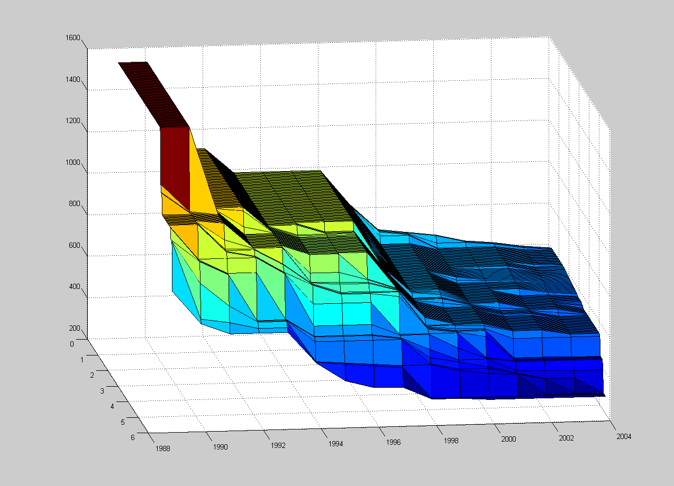
Figure 9a: Fitted response surface for all nitrogen (μg/L) and salinity (psu) data observed in September at the stations in the inner archipelago.

Figure 9b: Fitted nitrogen values illustrating how the monotonic nitrogen-salinity relationships changed from 1989 to 2004. The analysis was based on all September data from the inner archipelago.

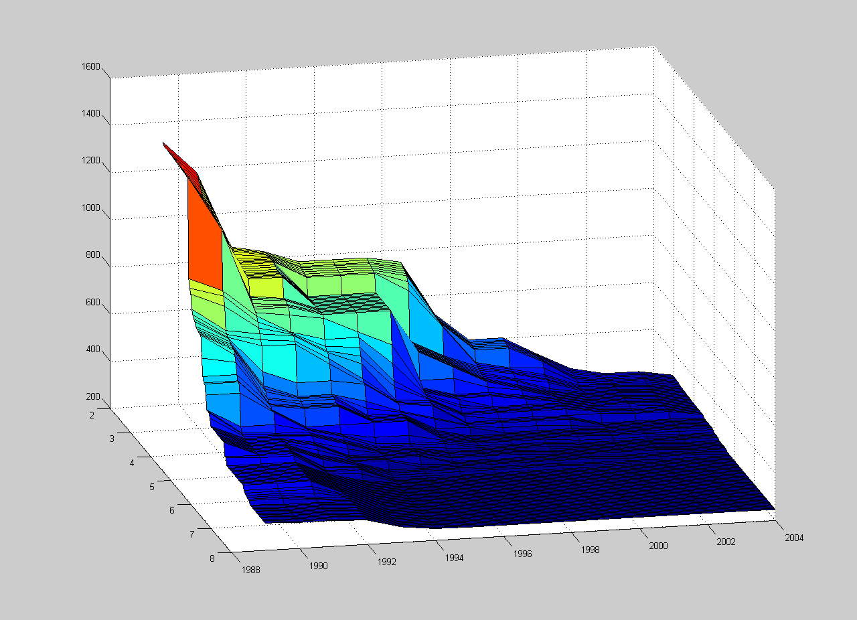
Figure 10a: Fitted response surface for all nitrogen and salinity data observed in September at the stations in the outer archipelago.

Figure 10b: Fitted nitrogen values illustrating how the monotonic nitrogen-salinity relationships changed from 1989 to 2004. The analysis was based on all September data from the outer archipelago.

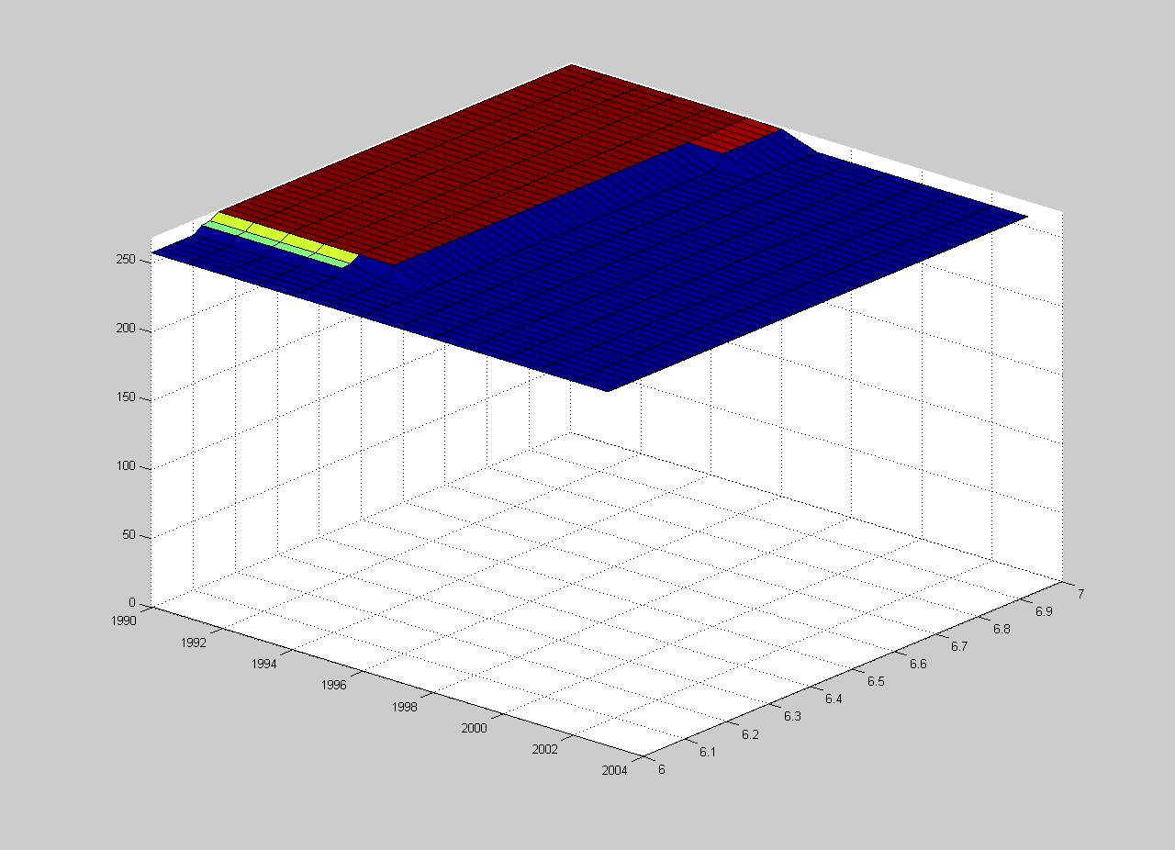
Figure 11a. Fitted response surface for all nitrogen and salinity data observed in September the reference station (Landsort).

Figure 11b: Fitted nitrogen values illustrating how the monotonic nitrogen-salinity relationships changed from 1989 to 2004. The analysis was based on all September data from the reference site (Landsort).

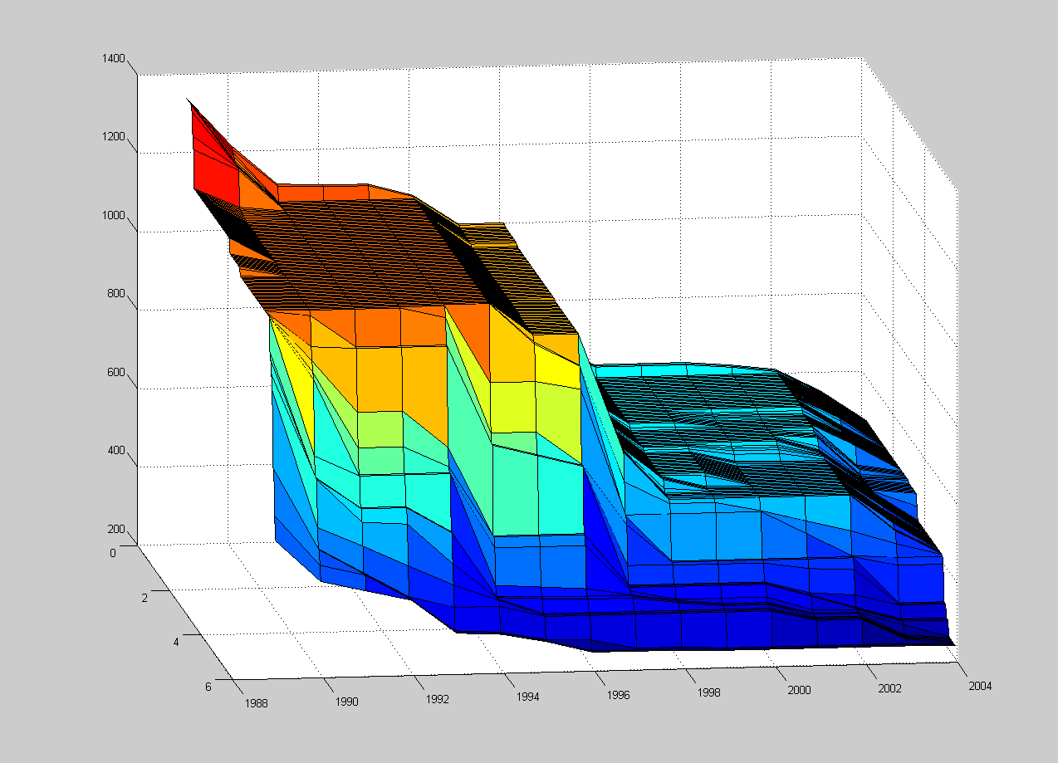
Figure 12a: Fitted response surface for all nitrogen and salinity data observed in June at the stations in the inner archipelago.

Figure 12b: Fitted nitrogen values illustrating how the monotonic nitrogen-salinity relationships changed from 1989 to 2004. The analysis was based on all June data from the inner archipelago.
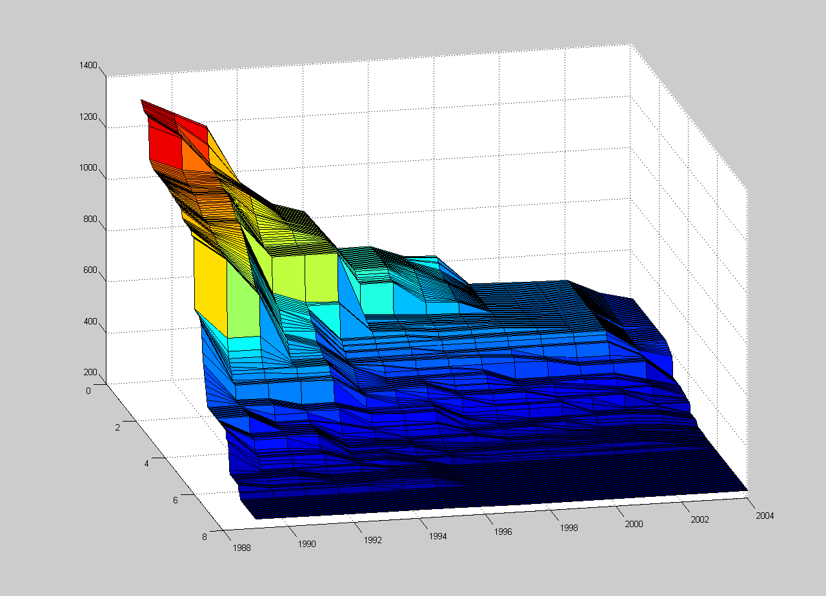
Figure 13a: Fitted response surface for all nitrogen and salinity data observed in June at the stations in the outer archipelago.

Figure 13b: Fitted nitrogen values illustrating how the monotonic nitrogen-salinity relationships changed from 1989 to 2004. The analysis was based on all June data from the outer archipelago.
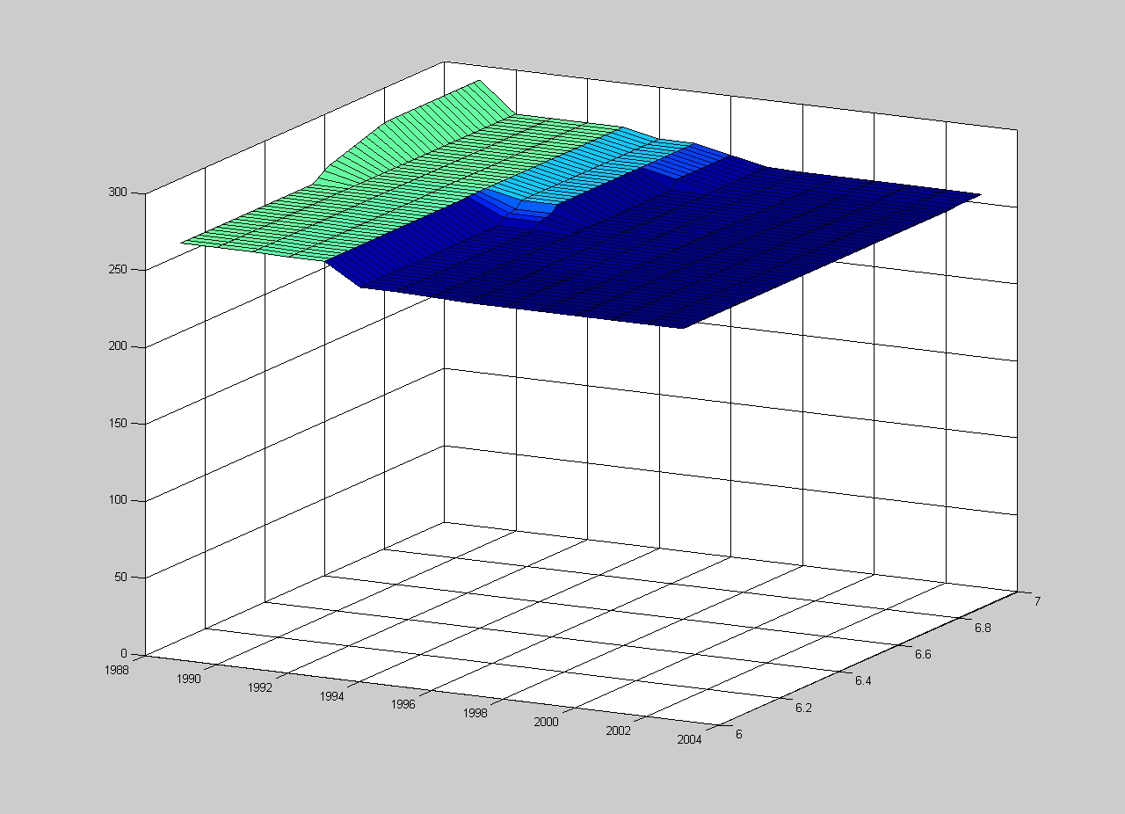
Figure 14a: Fitted response surface for all nitrogen and salinity data observed in June at the reference station.

Figure 14b: Fitted nitrogen values illustrating how the monotonic nitrogen-salinity relationships changed from 1989 to 2004. The analysis was based on all June data from the reference site (Landsort).

Trend tests
The statistical significance of nitrogen trends at individual stations was assessed using the Mann-Kendall test for monotonic trends in seasonal data (Hirsch and Slack, 1984) and the Partial Mann-Kendall (PMK) test (Libiseller and Grimvall, 2002). The latter test enables trend assessment in the presence of a covariate (salinity, in our case).

The obtained results are presented separately for the inner and the outer archipelago, and for the reference site (Table 3). As can be seen, a downward trend was detected at all stations in the archipelago, but not at the reference site (Landsort, in the Baltic Sea). P-values for the tests conducted for the inner archipelago were generally smaller than those obtained for the outer archipelago.

Table 3a: Mann-Kendall tests for trends in total nitrogen at the monitoring sites in the inner archipelago.

 | MK | p-value | PMK | p-value
Älvvik | -4.105 | 0.00004 | -3.212 | 0.00066
Blockhusudden | -3.994 | 0.00006 | -3.206 | 0.00067
Blomskär | -3.981 | 0.00007 | -3.065 | 0.00109
Ekhagen | -4.150 | 0.00003 | -3.156 | 0.0008
Halvkakssundet | -4.035 | 0.00005 | -3.115 | 0.00092
Karantänbojen | -4.016 | 0.00006 | -3.002 | 0.00134
Koviksudde | -3.874 | 0.00011 | -2.829 | 0.00234
Koviksudde – veckostation | -3.988 | 0.00007 | -3.815 | 0.00007
Norra Vaxholmsfjärden | -3.744 | 0.00018 | -3.606 | 0.00016
Slussen | -3.903 | 0.00010 | -3.222 | 0.00064
Södra Vaxholmsfjärden | -3.931 | 0.00008 | -3.677 | 0.00012
Solöfjärden | -3.931 | 0.00008 | -2.823 | 0.00238
V Torsbyholmen | -3.897 | 0.00010 | -3.512 | 0.00022

Table 3b: Mann-Kendall tests for temporal trends in nitrogen at the monitoring sites in the outer archipelago.

 | MK | p-value | PMK | p-value
Åkerviksudde – veckostation | -3.274 | 0.00106 | -2.618 | 0.00442
Franska Stenarna | -2.616 | 0.00889 | -2.278 | 0.01135
Ikorn | -3.200 | 0.00138 | -2.611 | 0.00451
Kanholmsfjärden | -3.469 | 0.00052 | -3.376 | 0.00037
NV Eknö | -3.350 | 0.00081 | -2.206 | 0.01371
Nyvarp | -3.582 | 0.00034 | -2.397 | 0.00827
SO Österskär | -3.634 | 0.00028 | -3.059 | 0.00111
Sollenkroka | -3.268 | 0.00108 | -2.196 | 0.01405
Trälhavet II | -3.661 | 0.00025 | -2.495 | 0.00630
Trälhavet – veckostation | -3.870 | 0.00011 | -3.548 | 0.00019
Växlet – veckostation | -3.067 | 0.00216 | -2.109 | 0.01748

Table 3c: Mann-Kendall tests for temporal trends in nitrogen at the reference site.

 | MK | p-value | PMK | p-value
Landsort | -0.430 | 0.667 | 0.522 | 0.602

The response surfaces presented in Figures 9 – 14 indicated that the trend slopes were different at different salinity levels. This was further investigated by computing Sen's slope (Hirsch et al, 1982). To be more precise, the slope was determined for three salinity levels: 0-3 psu, 3-5 psu and more than 5 psu. It can be seen that the largest change occurred in the medium saline waters both in the inner and outer archipelago (Table 4). Moreover, the general trend was much steeper in the inner archipelago. However, it should be noted that Sen’s slope for the salinity level 0-3 psu in the outer archipelago is very uncertain due to the small number of observations for that combination of salinity and area.

Table 4. Average temporal trend in nitrogen (μg/L/yr) determined as Sen's slope.

 | Salinity level (psu)
 | 0-3 | 3-5 | > 5
Inner archipelago | -30 | -45 | -25
Outer archipelago | -12 | -20 | -7

Other tests were conducted to examine whether the nitrogen trends differed with sampling depth or time of the year. In the inner archipelago, trends had the largest magnitude in the surficial waters (0 - 20 m), whereas in the outer archipelago no difference could be seen for the different depths, except for the deepest waters (60 – 100 m) where few observations were available.

Conclusions
Clear downward trends in the concentration of total nitrogen were found at almost all stations in the inner and outer parts of the Stockholm archipelago, whereas no trend was detected at the reference site (Landsort) in the Baltic Sea.

At the monitoring sites in the inner archipelago, the detected trends coincided well in time with the implementation of improved nitrogen removal at wastewater treatment plants. Furthermore, a dramatic reduction in total nitrogen levels was found for all month in this region.

The downward trend in nitrogen levels in the outer archipelago is statistically strongly significant. However, it is more uncertain when the major changes took place and to what extent the observed trend was a direct consequence of the major changes in emissions in the mid 1990s. For some months, a drop in nitrogen occurred around 1996, whereas other months exhibited a drop already in the early 1990s.

References
Burdakov O., Sysoev O., Grimvall A., and Hussian M. (2005), An O(n²) algorithm for isotonic regression. Proceedings of an international conference on Large Scale Nonlinear Optimization, Erice, Italy.

Hirsch R. M. and Slack J. R. (1984), A nonparametric trend test for seasonal data with serial dependence. Water Resources Research 20, 727-732.

Hirsch R.M, Slack J. R., and Smith R.A (1982). Techniques of trend analysis for monthly water quality data. Water Resources Research 18. 107-121

Hussian M., Grimvall A., Burdakov O., and Sysoev O. (2004), Monotonic regression for assessment of trends in environmental quality data. European Congress on Computational Mehtods in Applied Sciences and Engineering (ECCOMAS) 2004. Jyväskylä, 24-28 July 2004.

Libiseller C. and Grimvall A. (2002). Performance of partial Mann-Kendall tests for trend detection in the presence of covariates. Environmetrics 13, 71-84.

Libiseller C. and Nordgaard A. (2003). Variance reduction for trend analysis of hydrochemical data from brackish waters. LIU-MAT-R-2003-02. Linköpings universitet.

Skärgårdsrapporten (2005), Undersökningar i Stockholms skärgård. (www.stockholmvatten.se; Vattenvård, Pdf-Archiv)

APPENDIX A: Response surface plots for all months
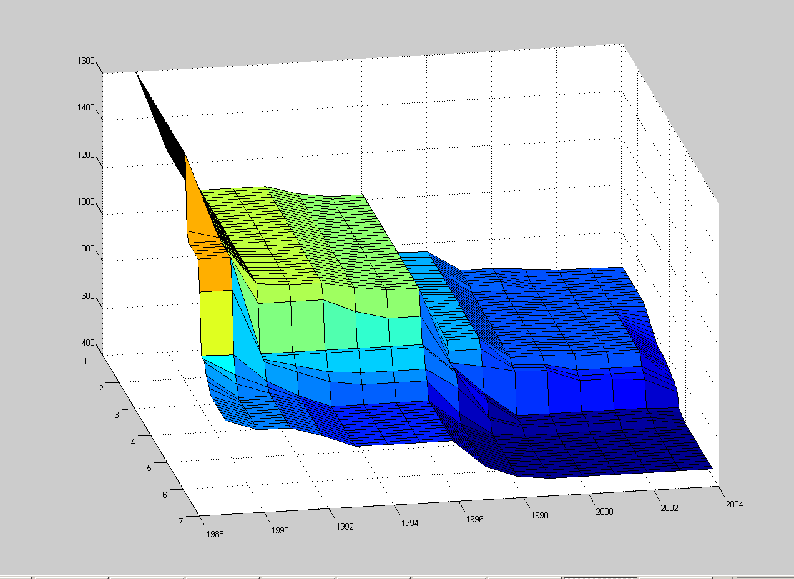
Figure A1: Fitted response surface for all nitrogen and salinity data observed in January at the stations in the inner archipelago.
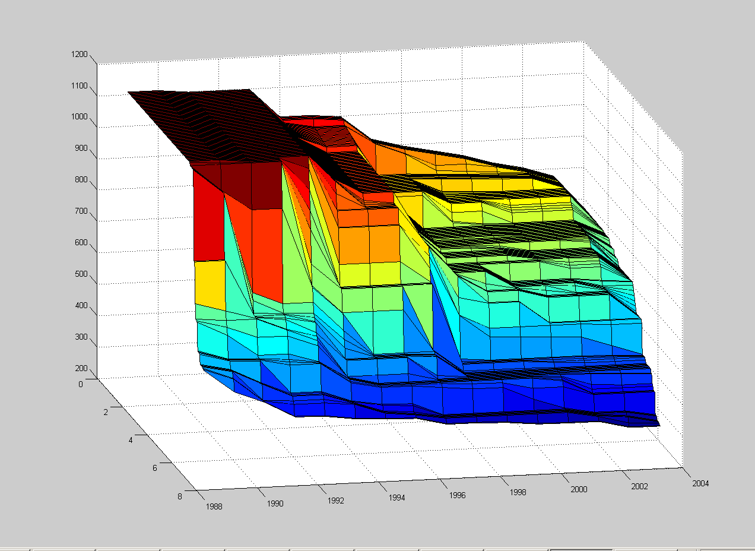
Figure A2: Fitted response surface for all nitrogen and salinity data observed in February at the stations in the inner archipelago.
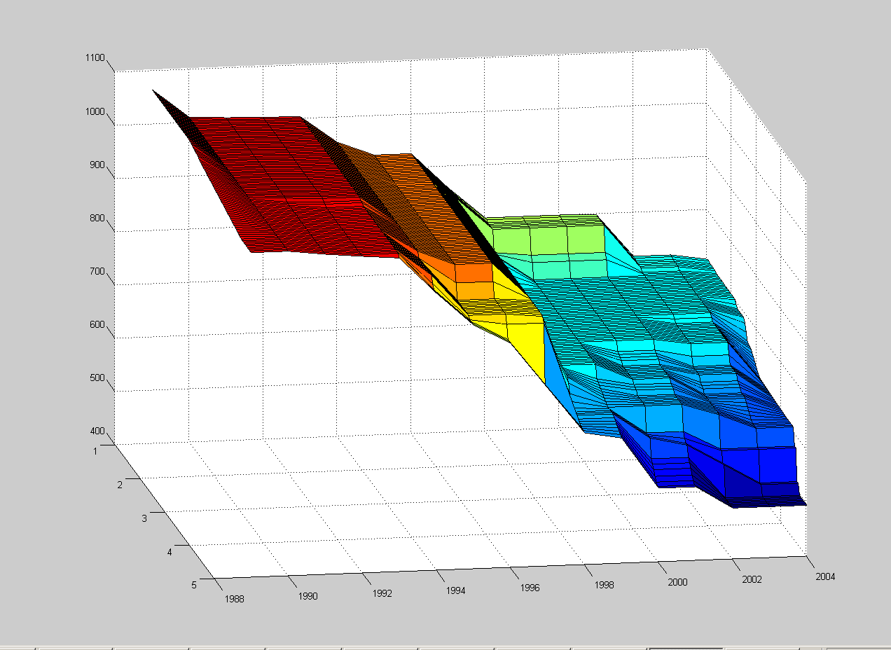
Figure A3: Fitted response surface for all nitrogen and salinity data observed in March at the stations in the inner archipelago. 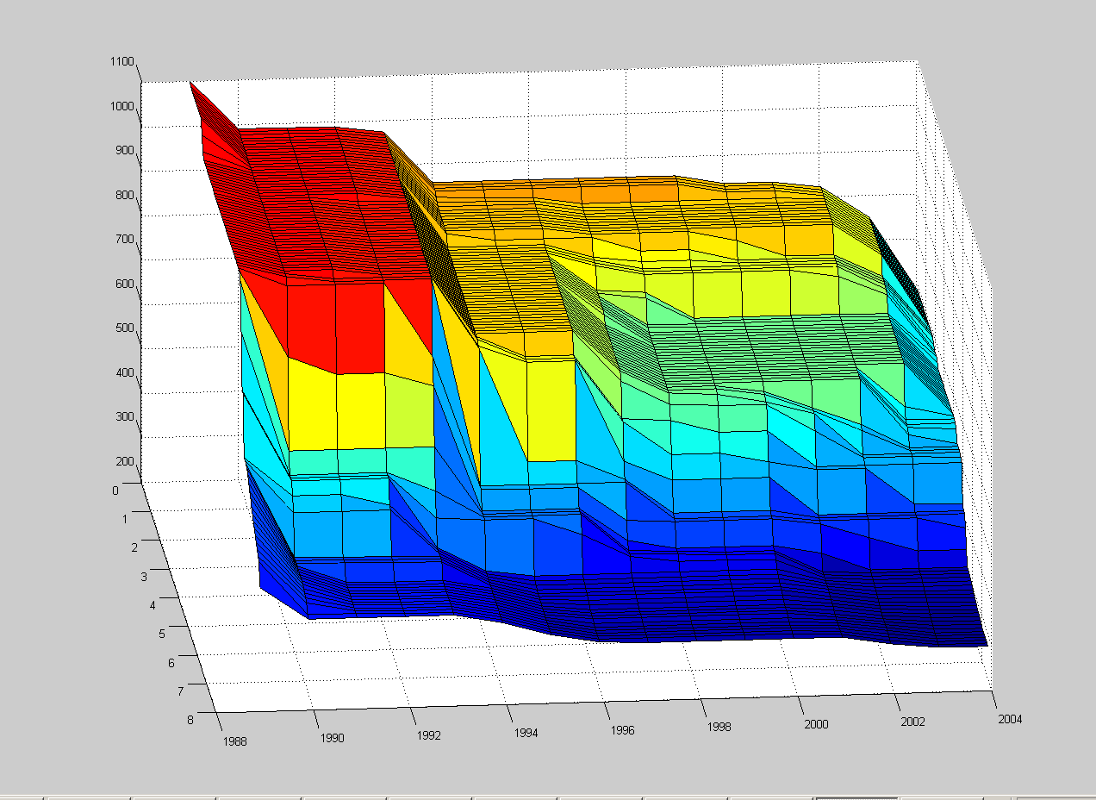
Figure A4: Fitted response surface for all nitrogen and salinity data observed in April at the stations in the inner archipelago.
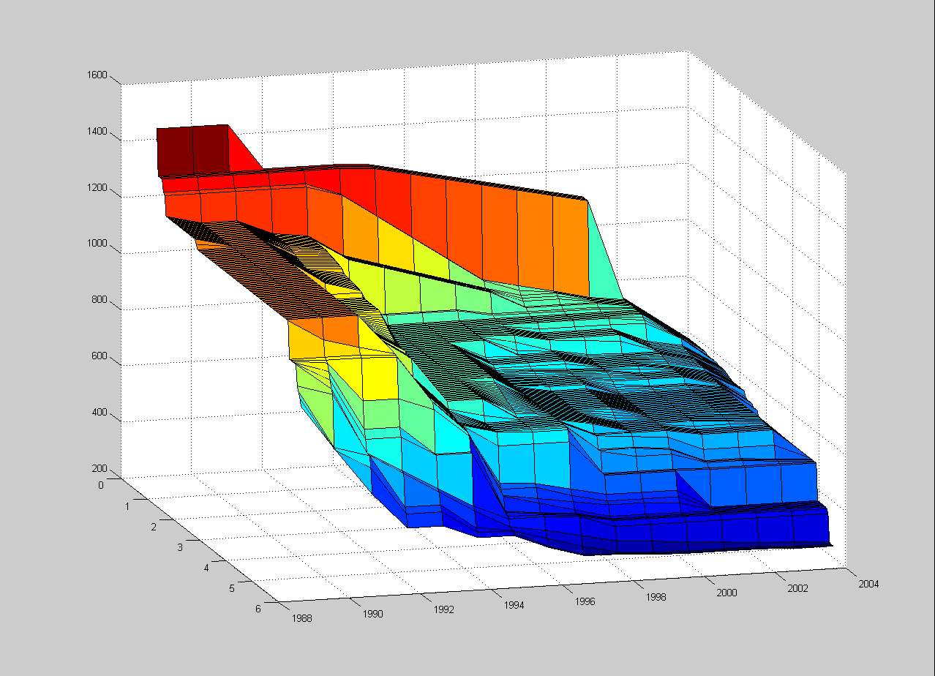
Figure A5: Fitted response surface for all nitrogen and salinity data observed in May at the stations in the inner archipelago.
Figure A6: Fitted response surface for all nitrogen and salinity data observed in June at the stations in the inner archipelago.
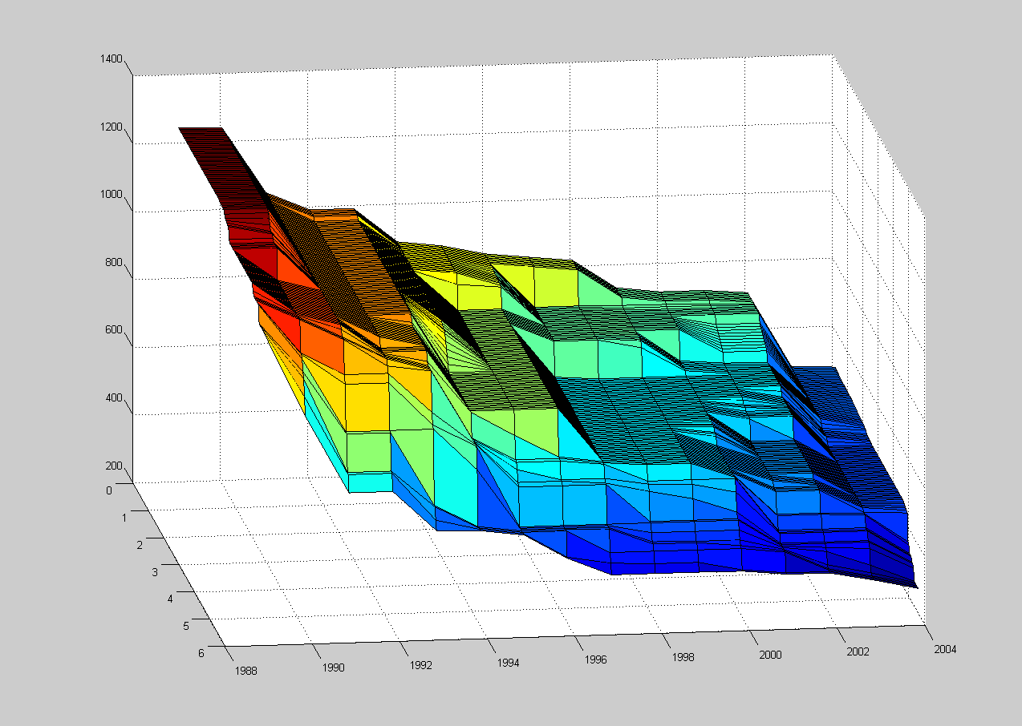
Figure A7: Fitted response surface for all nitrogen and salinity data observed in July at the stations in the inner archipelago.
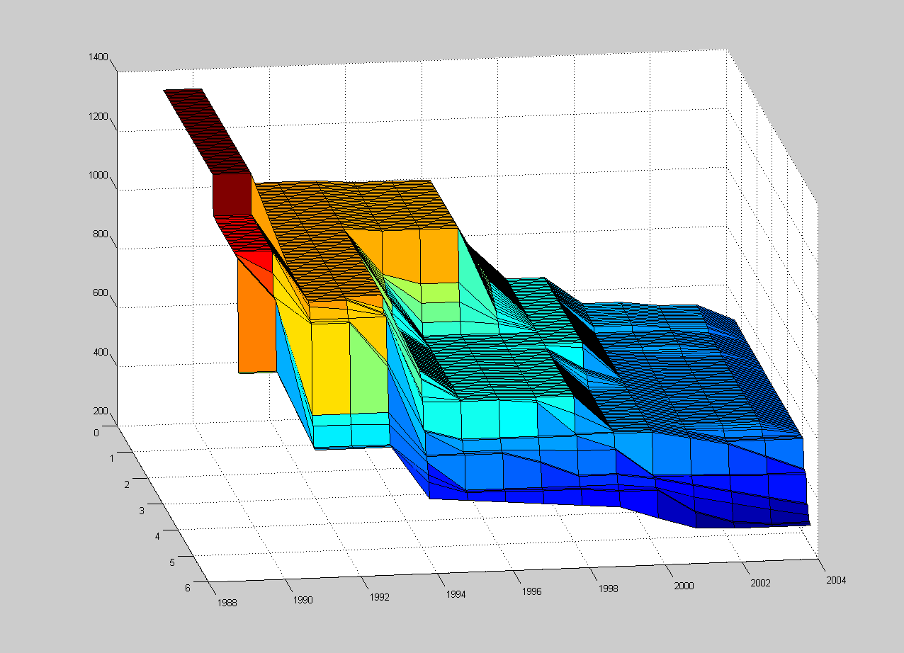
Figure A7. Fitted response surface for all nitrogen and salinity data observed in August at the stations in the inner archipelago
Figure A9. Fitted response surface for all nitrogen and salinity data observed in September at the stations in the inner archipelago.
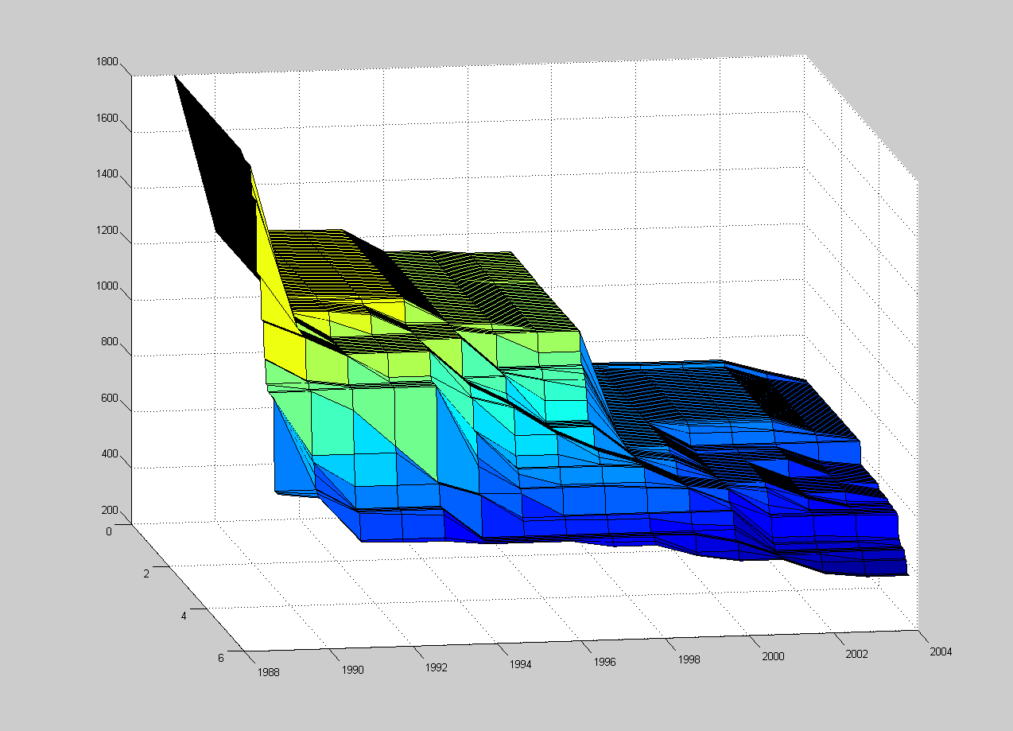
Figure A10. Fitted response surface for all nitrogen and salinity data observed in October at the stations in the inner archipelago.
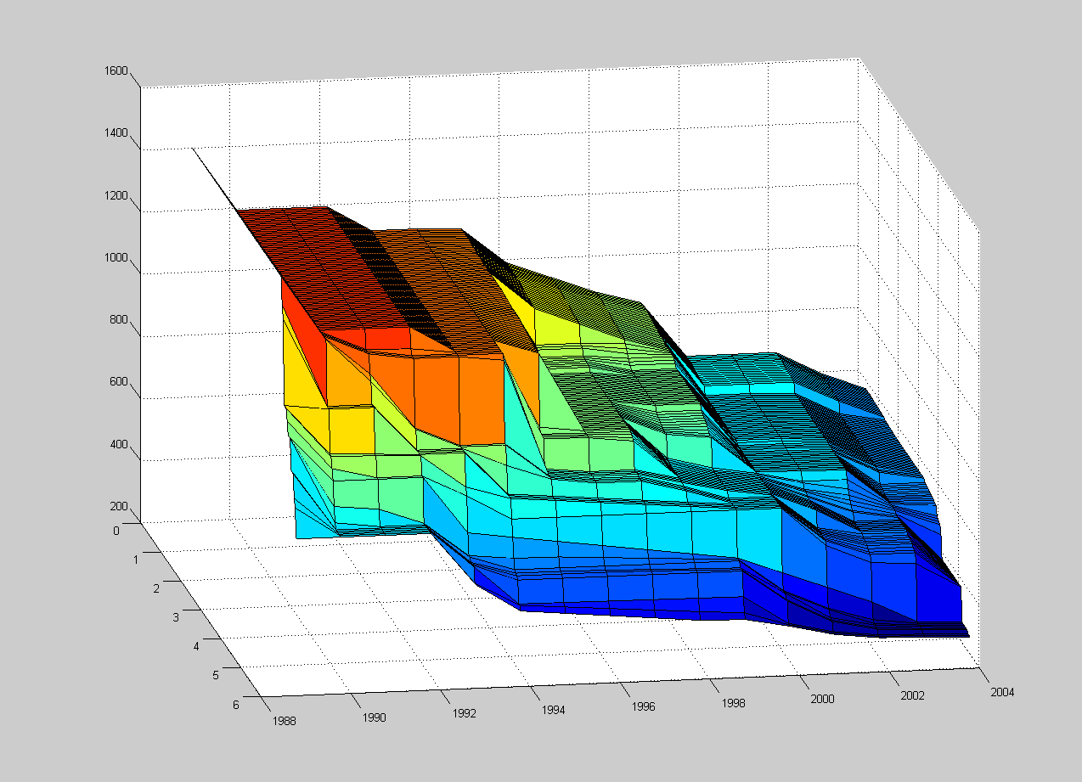
Figure A11. Fitted response surface for all nitrogen and salinity data observed in November at the stations in the inner archipelago.

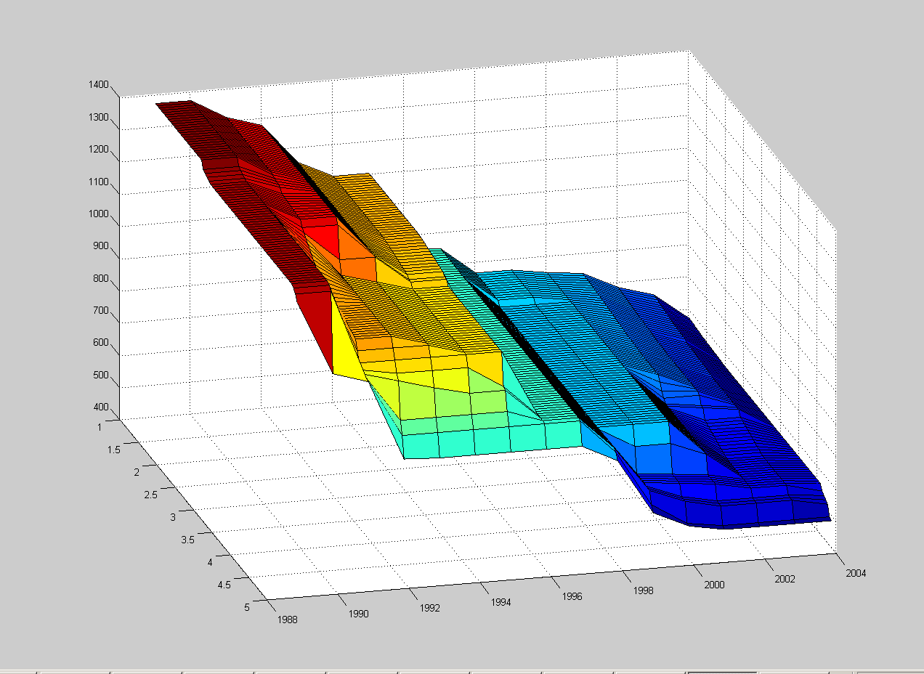
Figure A12. Fitted response surface for all nitrogen and salinity data observed in December at the stations in the inner archipelago.

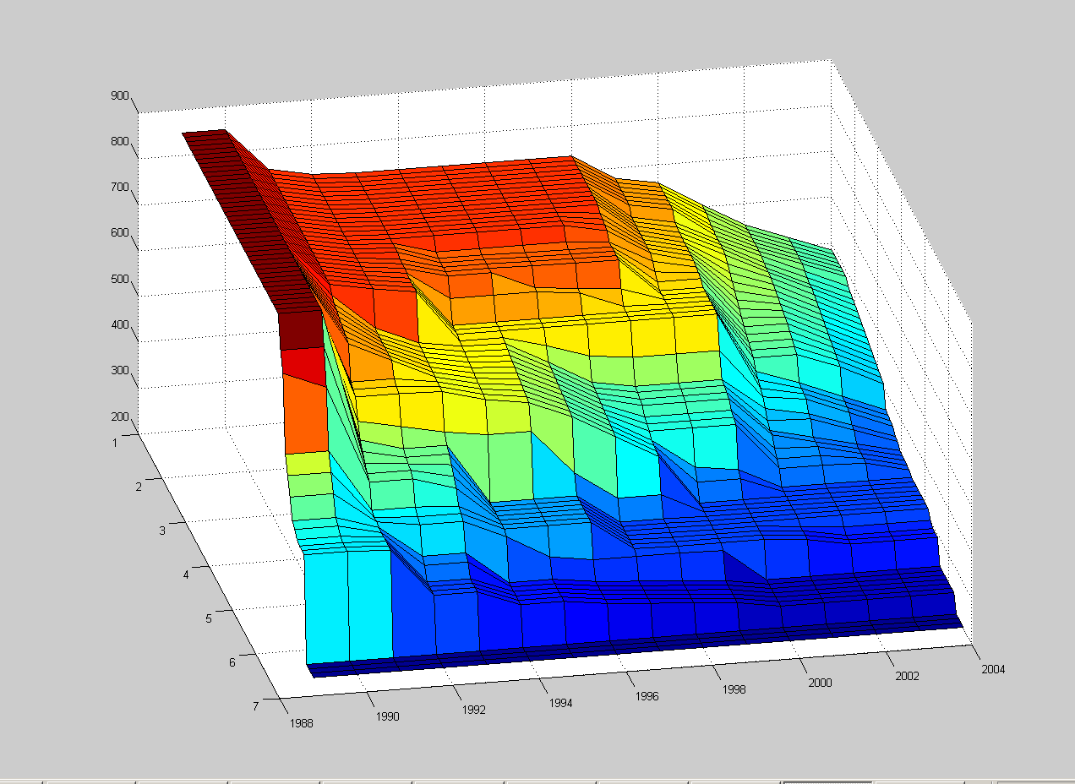
Figure A13: Fitted response surface for all nitrogen and salinity data observed in January at the stations in the outer archipelago.

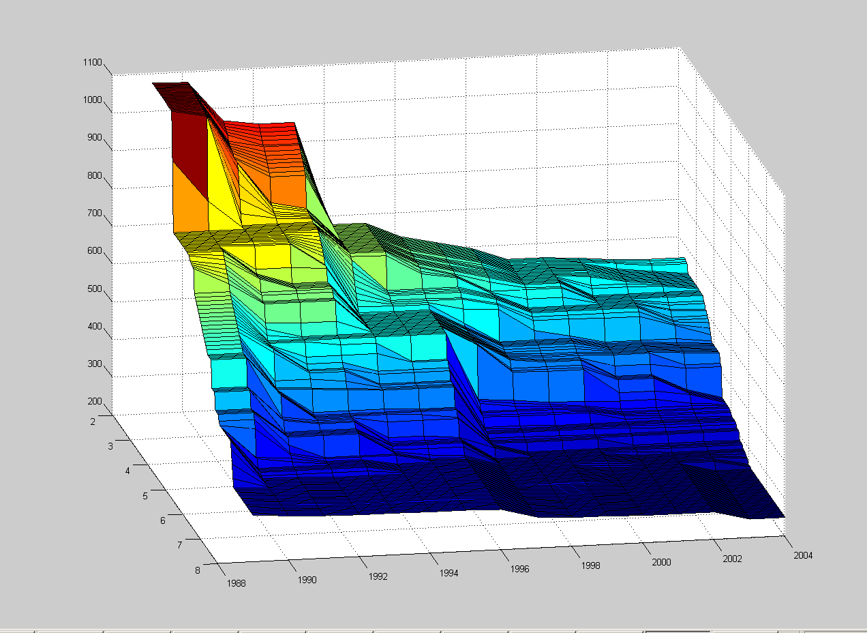
Figure A14: Fitted response surface for all nitrogen and salinity data observed in February at the stations in the outer archipelago.

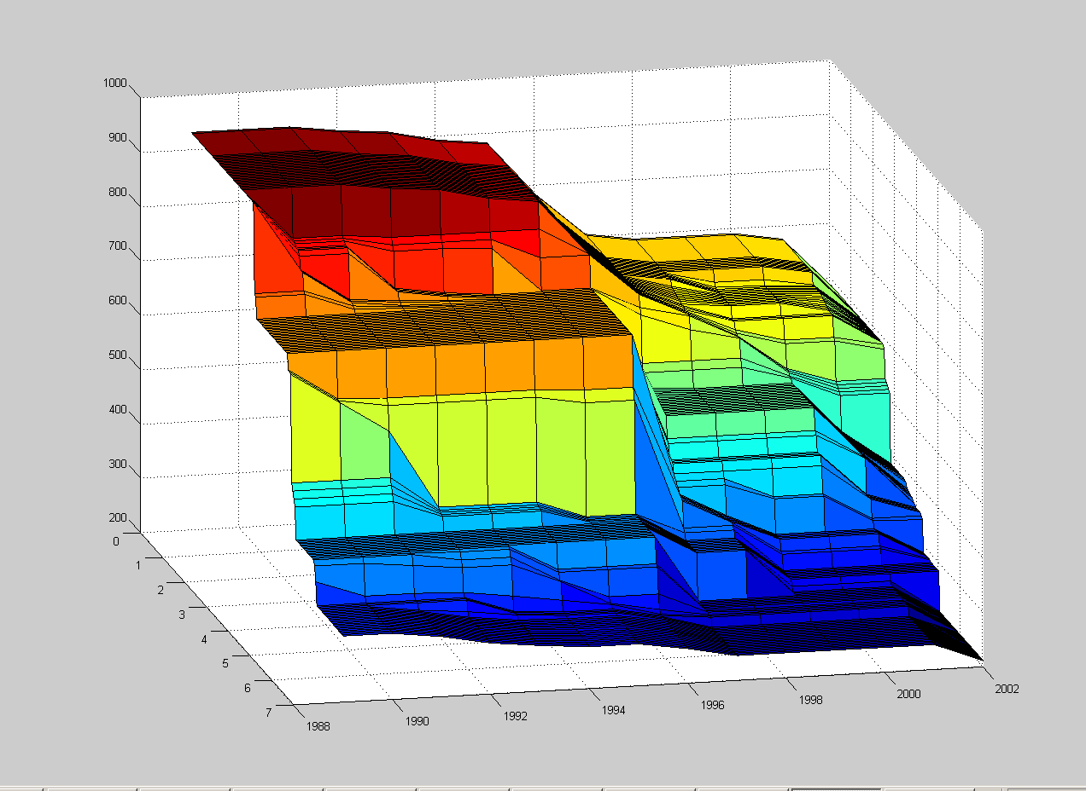
Figure A15: Fitted response surface for all nitrogen and salinity data observed in March at the stations in the outer archipelago.

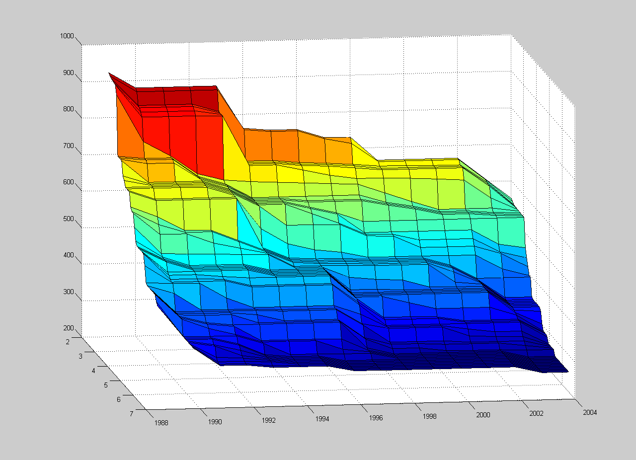
Figure A16: Fitted response surface for all nitrogen and salinity data observed in April at the stations in the outer archipelago.
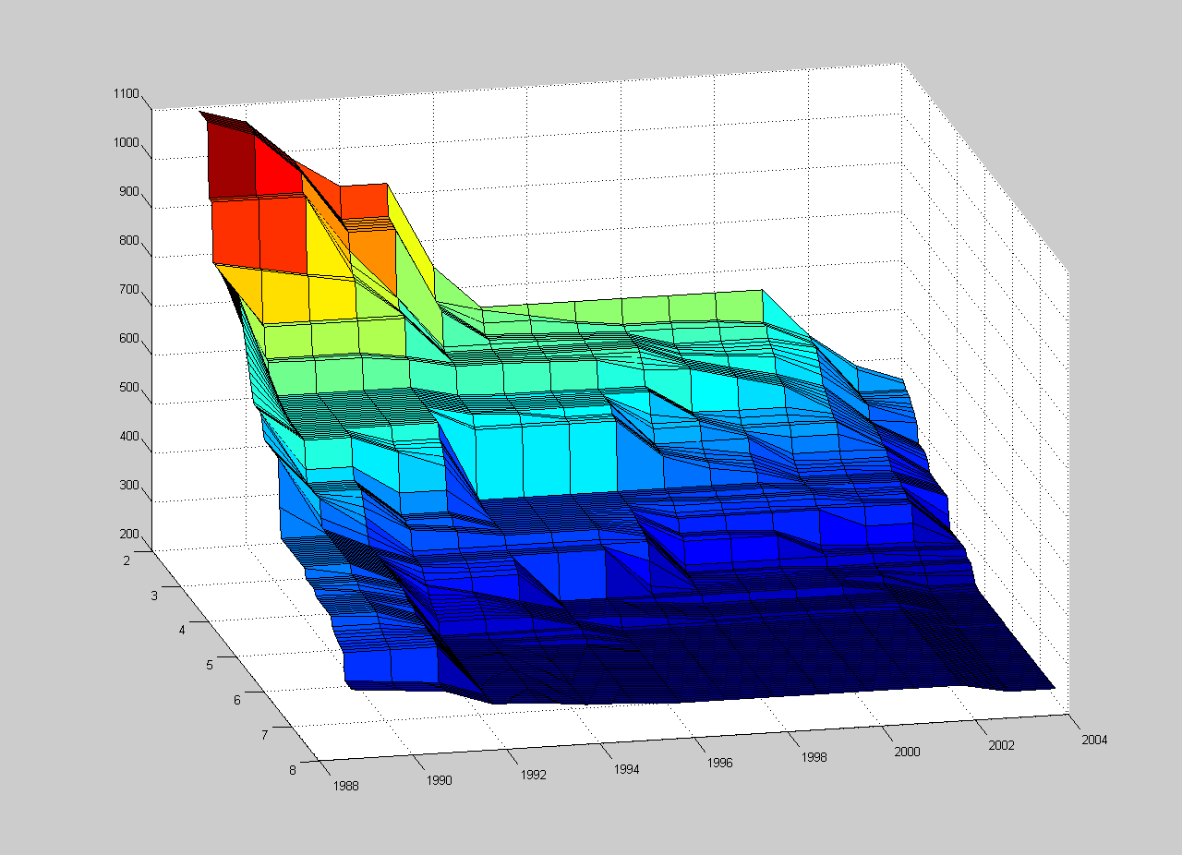
Figure A17: Fitted response surface for all nitrogen and salinity data observed in May at the stations in the outer archipelago.

Figure A18: Fitted response surface for all nitrogen and salinity data observed in June at the stations in the outer archipelago.
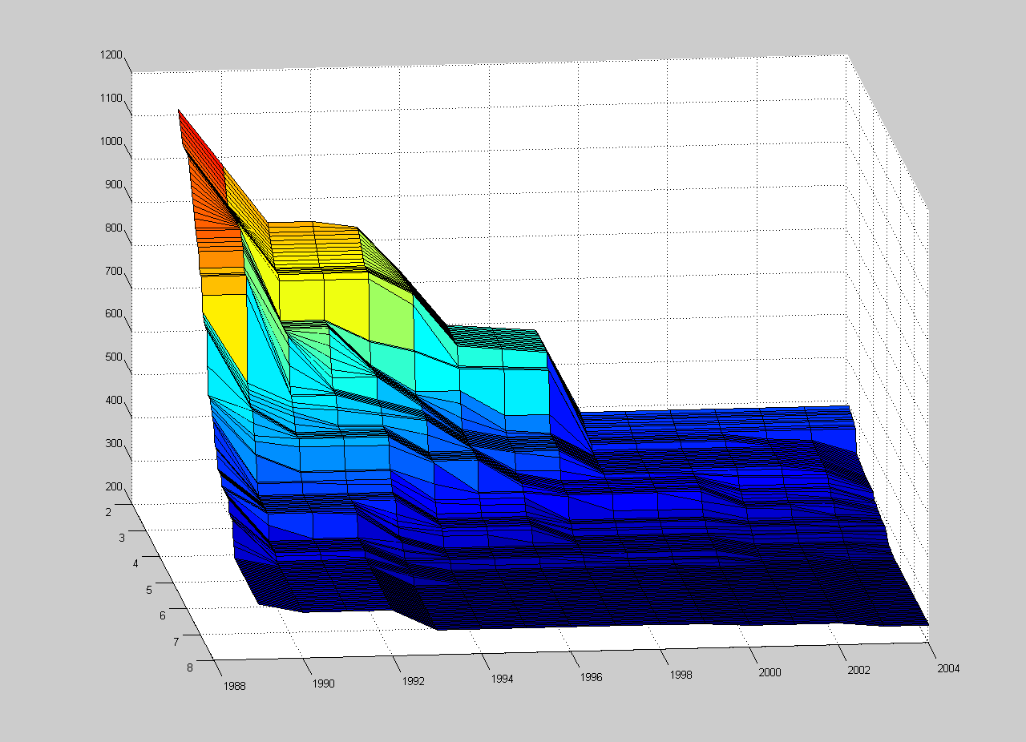
Figure A19: Fitted response surface for all nitrogen and salinity data observed in July at the stations in the outer archipelago.

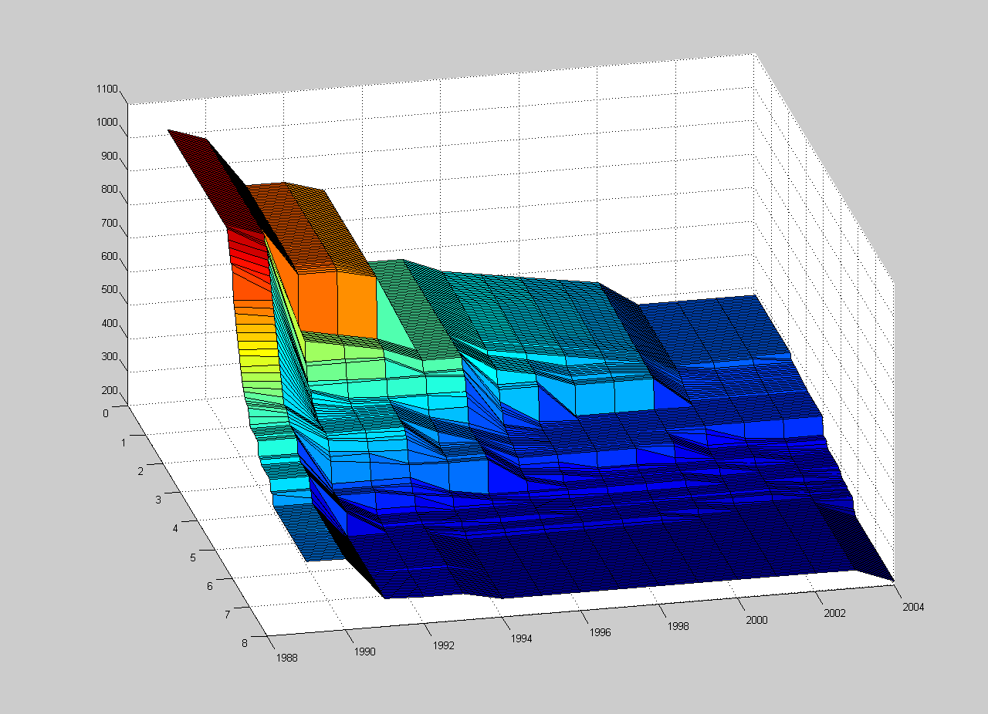
Figure A20: Fitted response surface for all nitrogen and salinity data observed in August at the stations in the outer archipelago.
Figure A21: Fitted response surface for all nitrogen and salinity data observed in September at the stations in the outer archipelago.

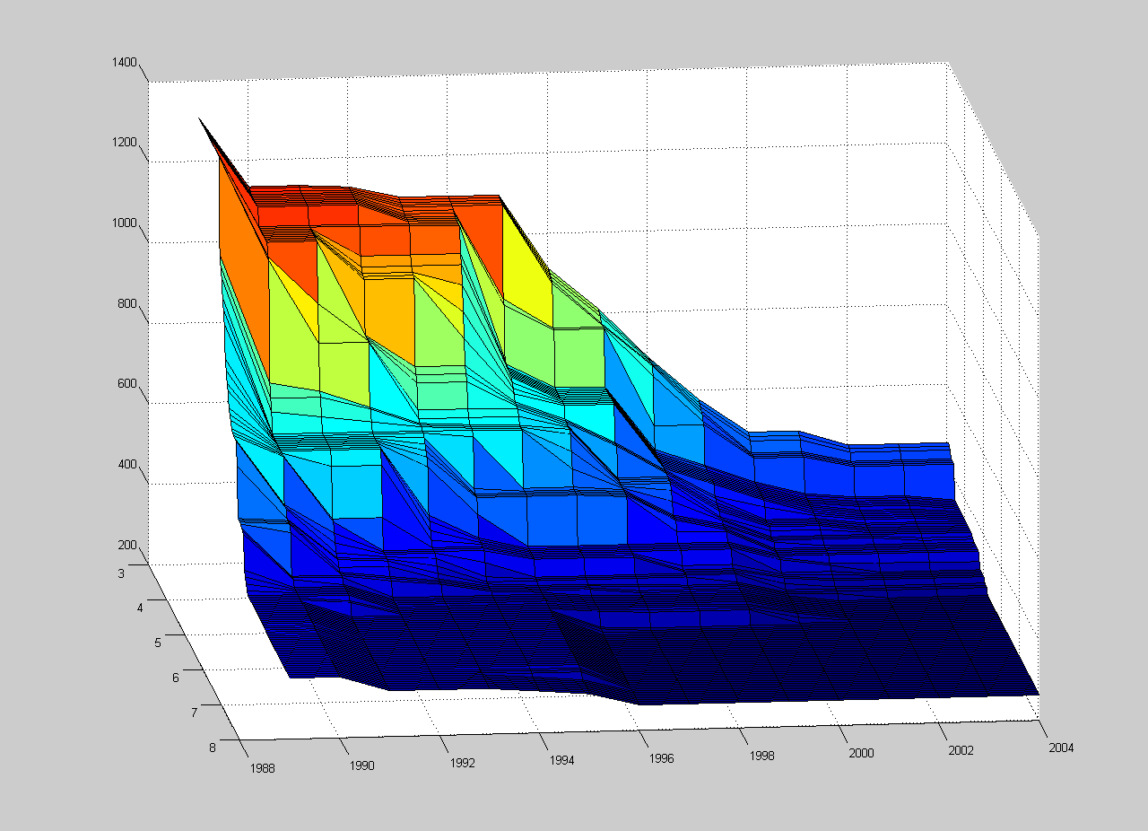
Figure A22: Fitted response surface for all nitrogen and salinity data observed in October at the stations in the outer archipelago.
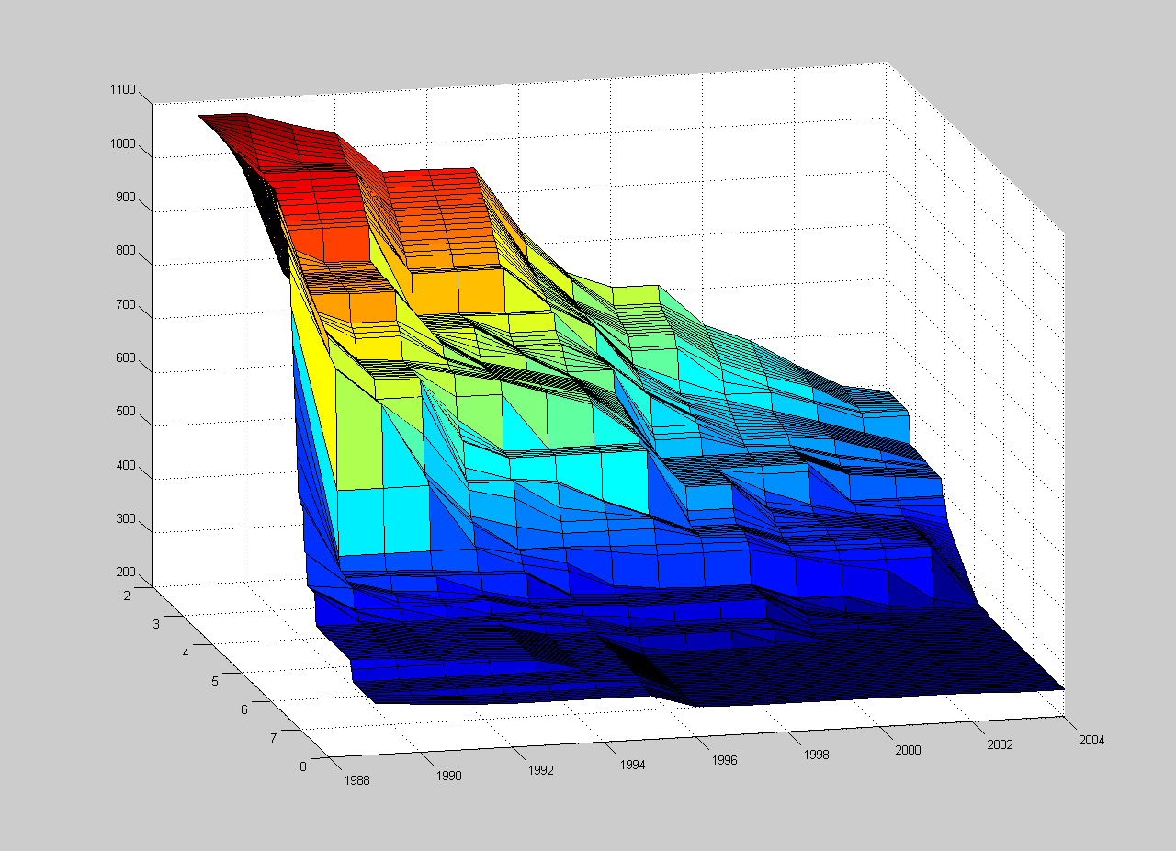
Figure A23: Fitted response surface for all nitrogen and salinity data observed in November at the stations in the outer archipelago.

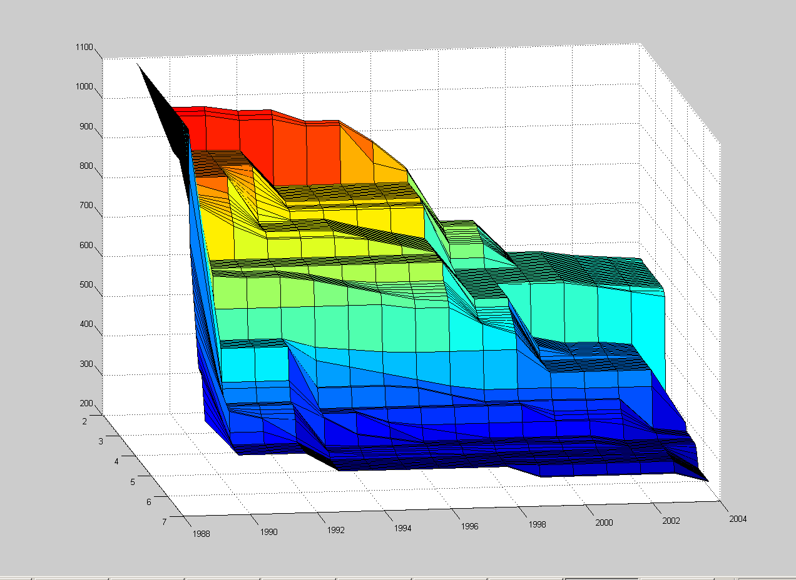
Figure A24: Fitted response surface for all nitrogen and salinity data observed in December at the stations in the outer archipelago.

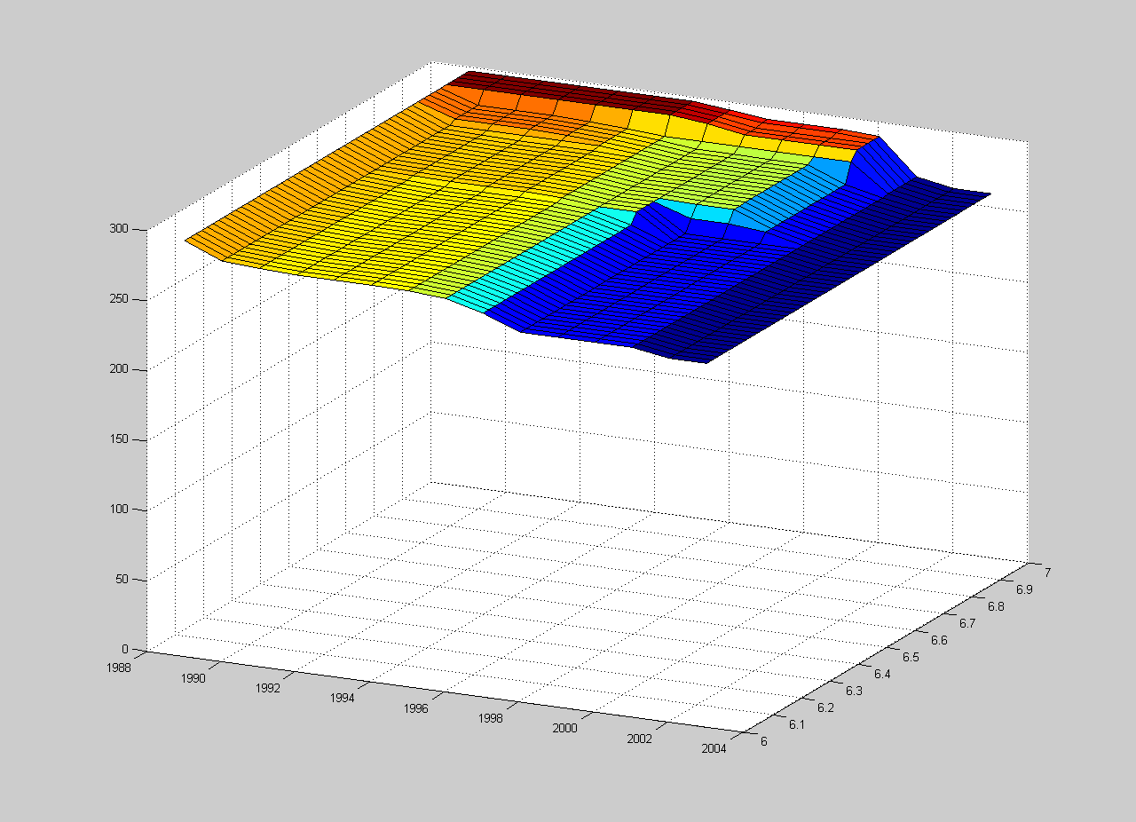
Figure A25: Fitted response surface for all nitrogen and salinity data observed in January at the reference site.

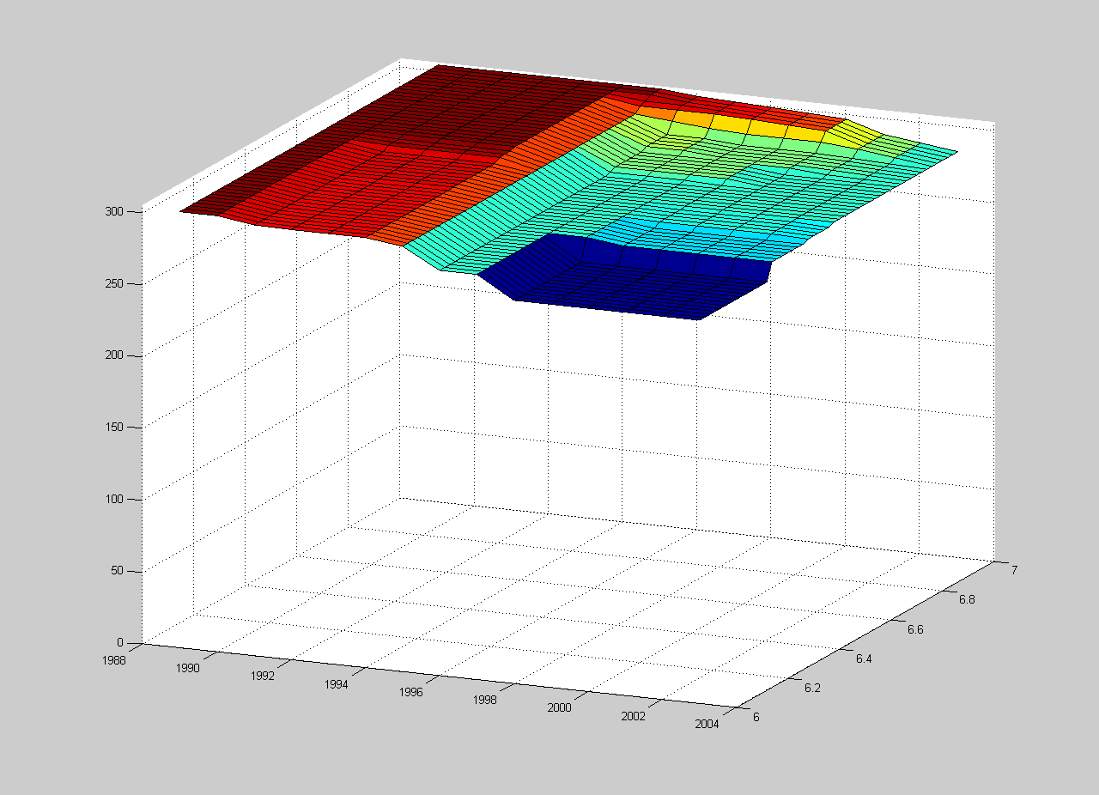
Figure A26: Fitted response surface for all nitrogen and salinity data observed in February at the reference site.

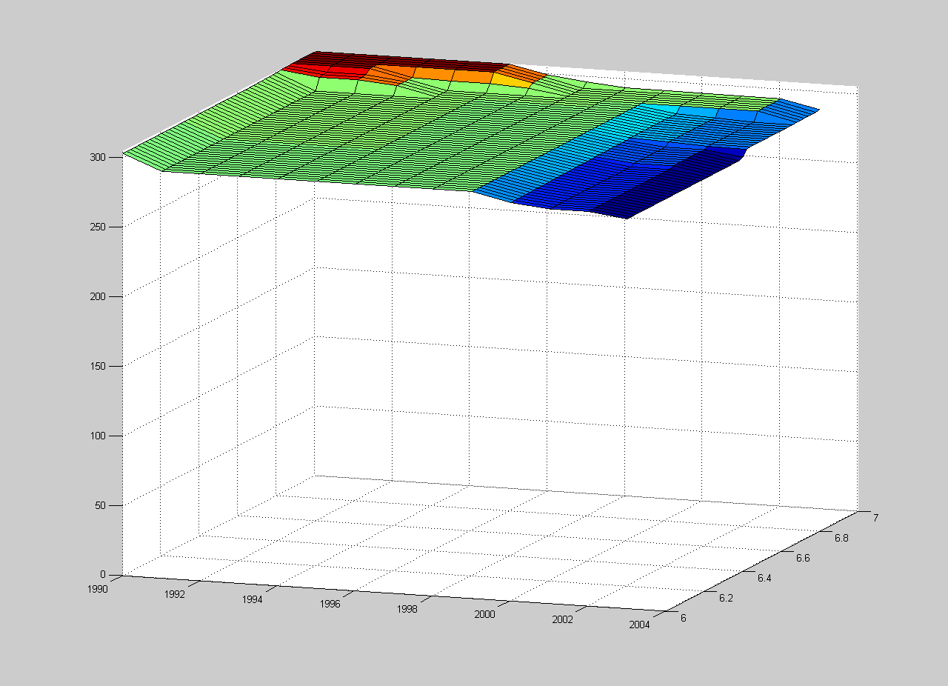
Figure A27: Fitted response surface for all nitrogen and salinity data observed in March at the reference site.
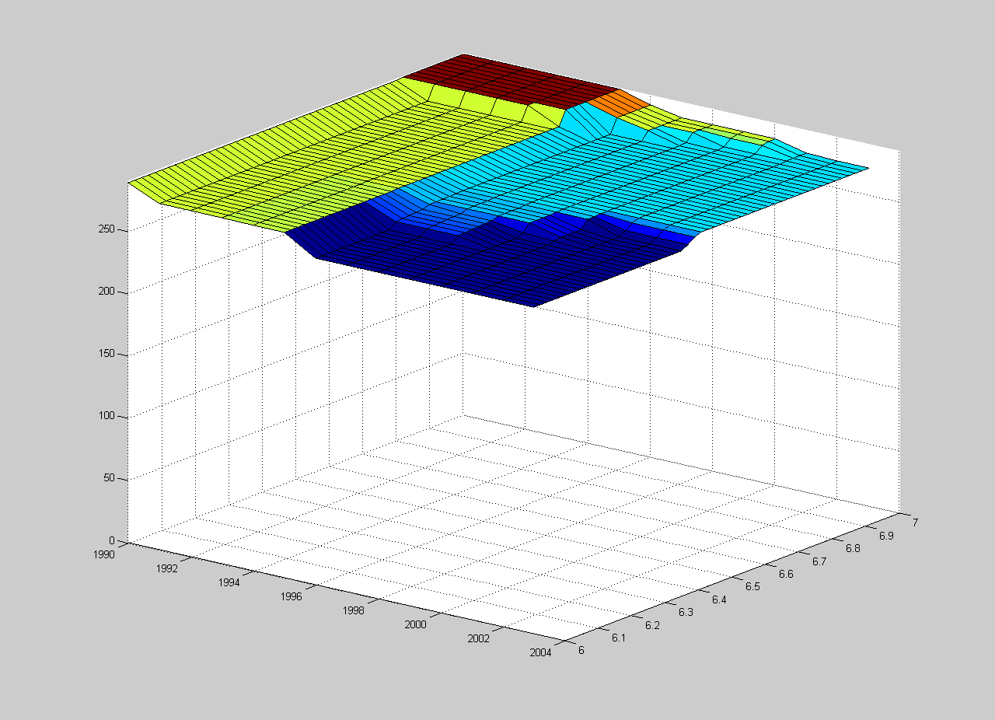
Figure A28: Fitted response surface for all nitrogen and salinity data observed in April at the reference site.

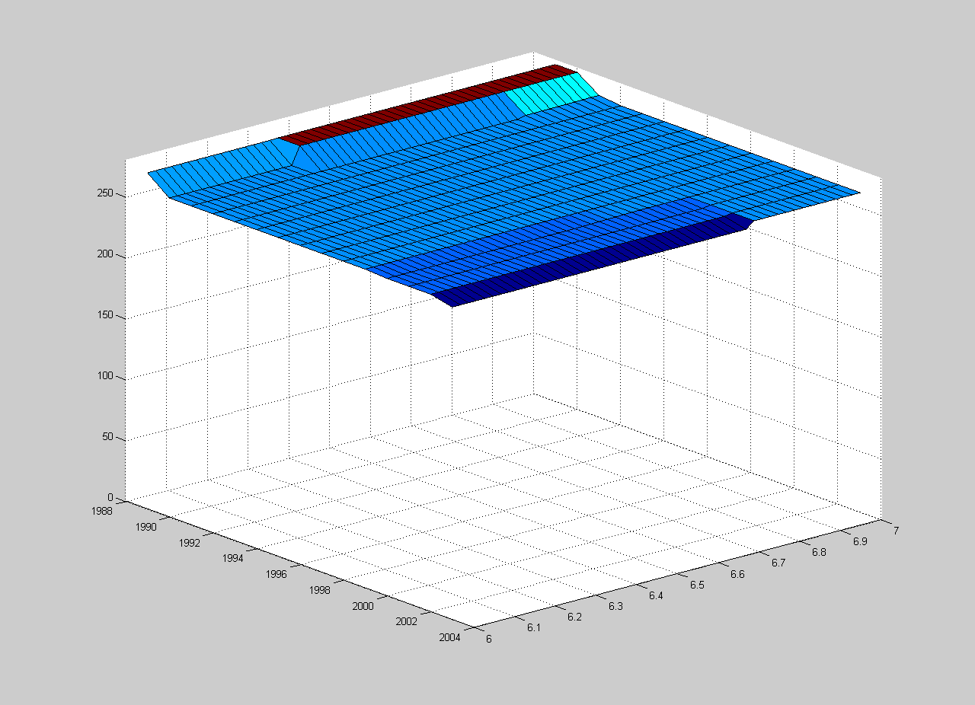
Figure A29: Fitted response surface for all nitrogen and salinity data observed in May at the reference site.
Figure A30: Fitted response surface for all nitrogen and salinity data observed in June at the reference site.

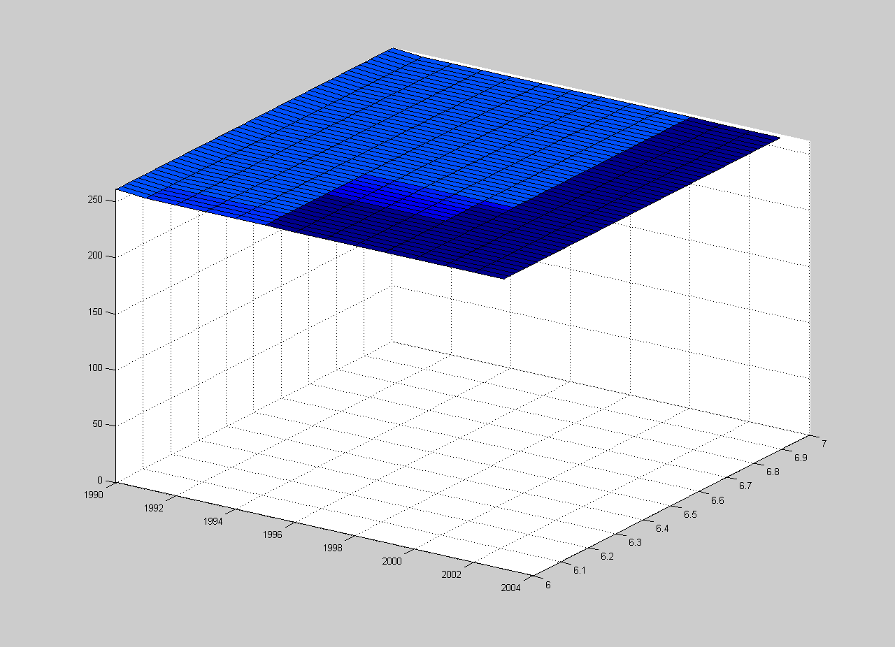
Figure A31: Fitted response surface for all nitrogen and salinity data observed in July at the reference site.
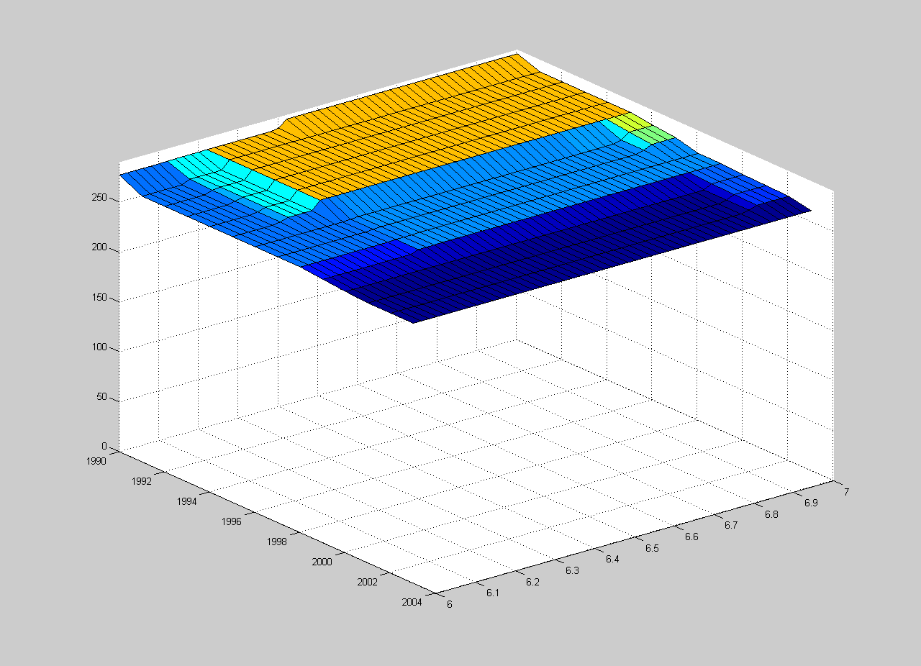
Figure A32: Fitted response surface for all nitrogen and salinity data observed in August at the reference site.

Figure A33: Fitted response surface for all nitrogen and salinity data observed in September at the reference site.
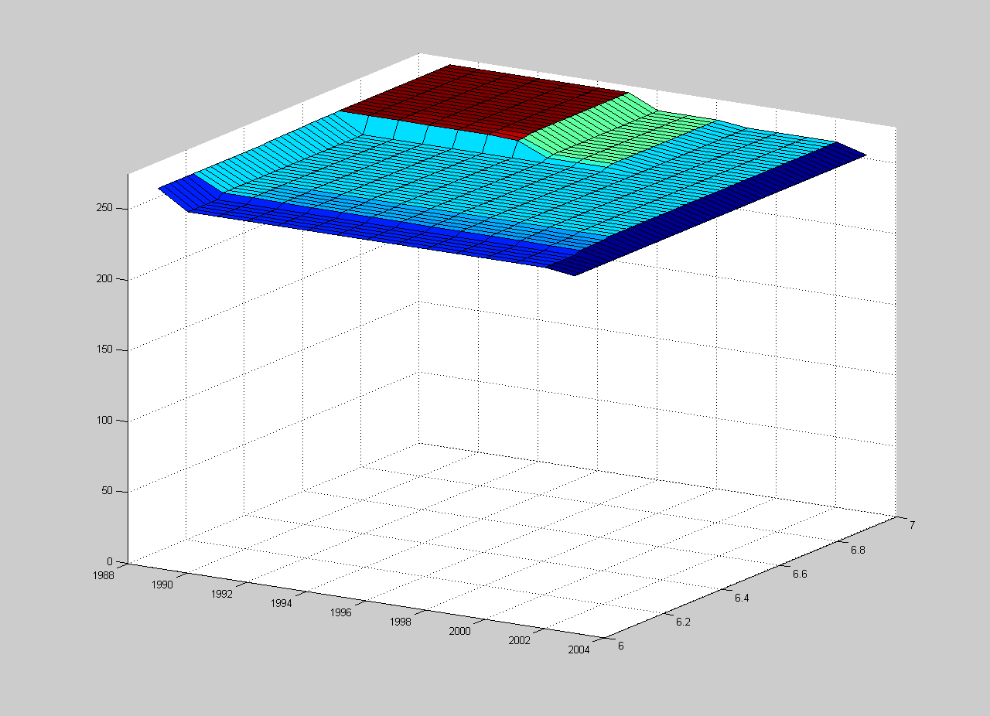
Figure A34: Fitted response surface for all nitrogen and salinity data observed in October at the reference site.

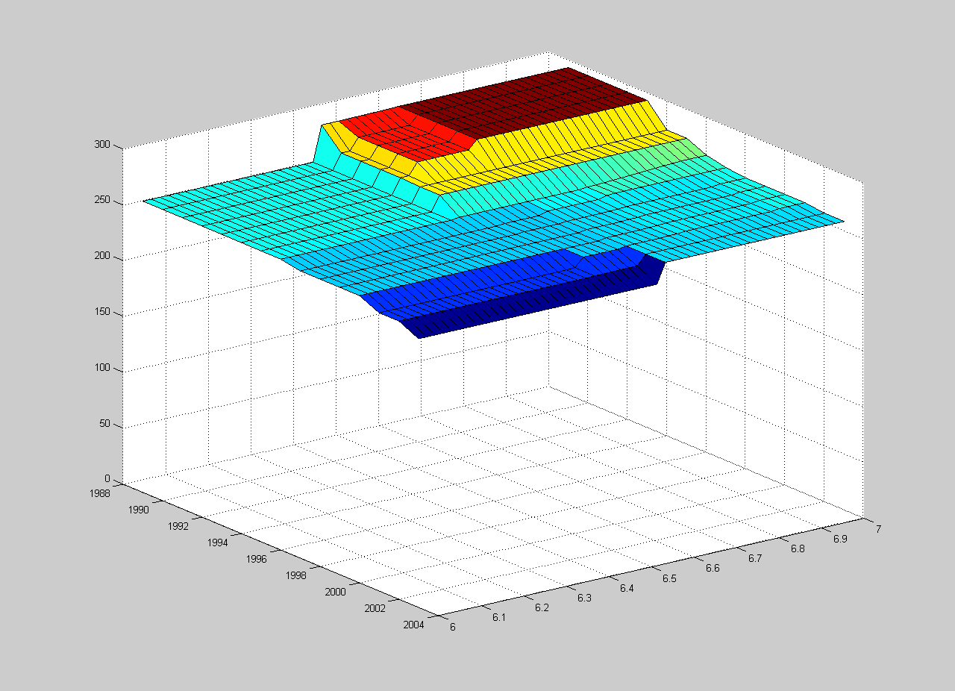
Figure A35: Fitted response surface for all nitrogen and salinity data observed in November at the reference site.
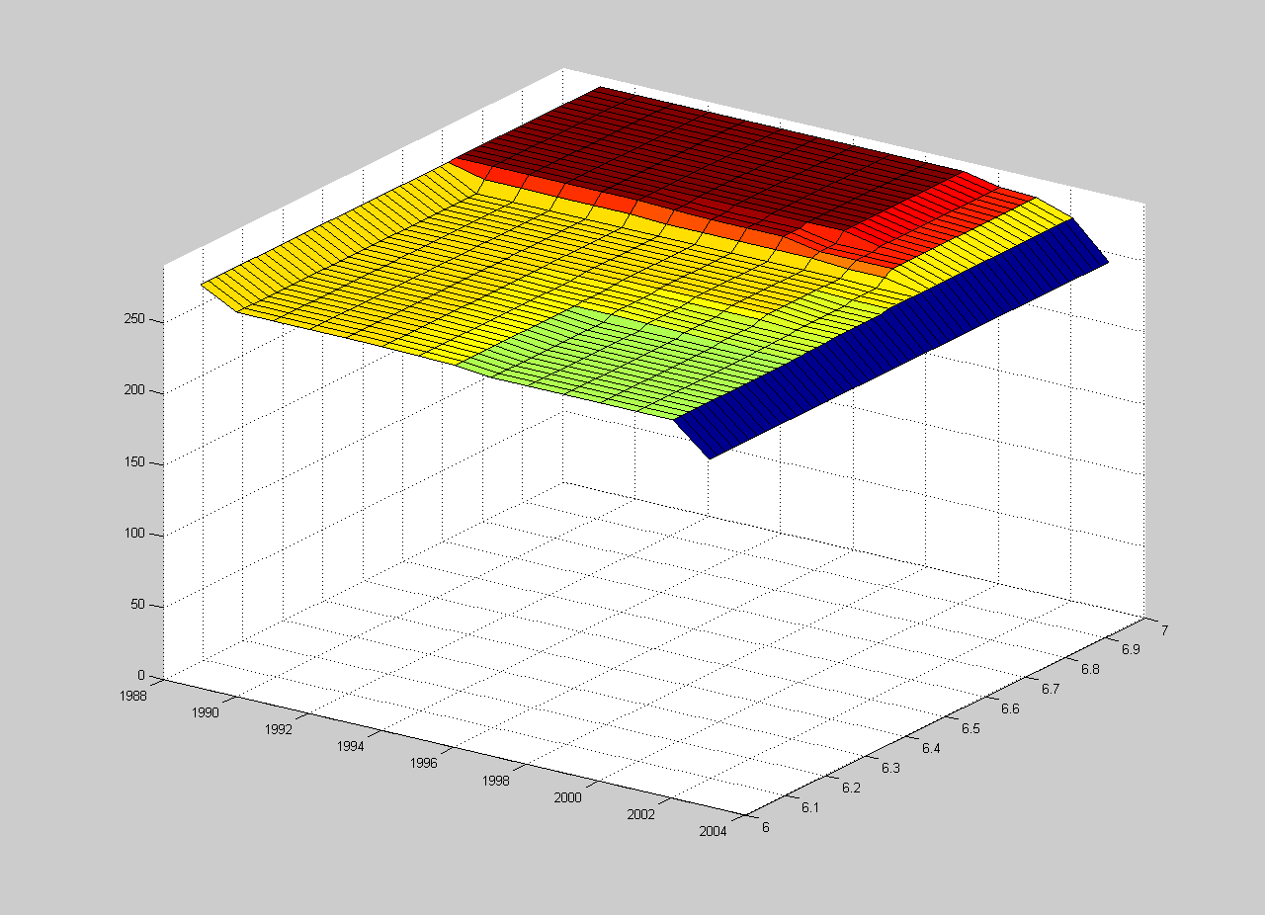
Figure A36: Fitted response surface for all nitrogen and salinity data observed in December at the reference site.

