Design and implementation of a
UML profile for Modelica/SysML

1 Introduction

  - Motivation
TODO
  - Thesis structure
TODO

- Background and Related Work

  - Modelica

This section provides a short introduction to Modelica language and its features. Two commercial Modelica simulation environments are described and an open source Modelica (OpenModelica) implementation project is presented.

    - The Modelica Language

Modelica is a multi-domain modeling and simulation language based on object-oriented language technology. The primarily purpose of Modelica is a declarative modeling of physical systems.

The Modelica design effort started in September 1996 by “Simulation in Europe Basic Research Working Group” within ESPRIT project. The language has been designed by the developers of different object-oriented modeling languages like Allan, Dymola, NMF, ObjectMath, Omola, SIDOPS+, Smile and other modeling and simulation experts. By December 1999 version 1.3 of Modelica language specification was finished. In February 2000, a non-governmental and a non-profit organization, named “Modelica Association” founded for further development and promotion of Modelica.

Modelica is an object-oriented language which supports class definition, class inheritance and generics templates. Models in Modelica can be described by differential, algebraic and discrete equations and also algorithms. In case of equations, no particular variable needs to be solved manually by developer, since Modelica Tool does it automatically. This feature of Modelica makes it attractive for domain modelers who get used to describe models in a declarative mathematical way.
Modelica has also a strong component model that allows composition of a system in a similar way as an engineer builds a real system by taking suitable components from manufactures catalogue and assembling them in a final system. For this purpose Modelica Association maintains free Modelica Library which contains components for different domains like electrical, mechanical, hydraulic, thermodynamic, etc. Modelica users may also develop and reuse their own libraries. An important feature of Modelica is that components from different domains can be composed within the same application model.

For more information about Modelica refer to Modelica Association website[X] or “Principles of Object-Oriented Modeling and Simulation with Modelica 2.1”[X] by Peter Fritzson.

    - Modelica Tools

      - MathModelica

MathModelica is a modeling and simulation environment developed by MathCore Engineering AB and consists of three major parts – Modelica Editor, Notebook and Simulation center [X]. MathModelica is shown on figure[X]. Modelica Editor is a graphical user interface for model composition using Modelica library components. In Modelica Editor it’s possible to specify parameters values to specific components and start simulation. A model diagram can be stored and then documented in Mathematica Notebook. MathModelica Notebook is used also for simulation scripting and model analysis. Integration of MathModelica with Mathematica provides the access to many useful functions that may be used by domain experts like linearization, sensitivity analysis, etc. Simulation Center part runs simulations on models and plots results.

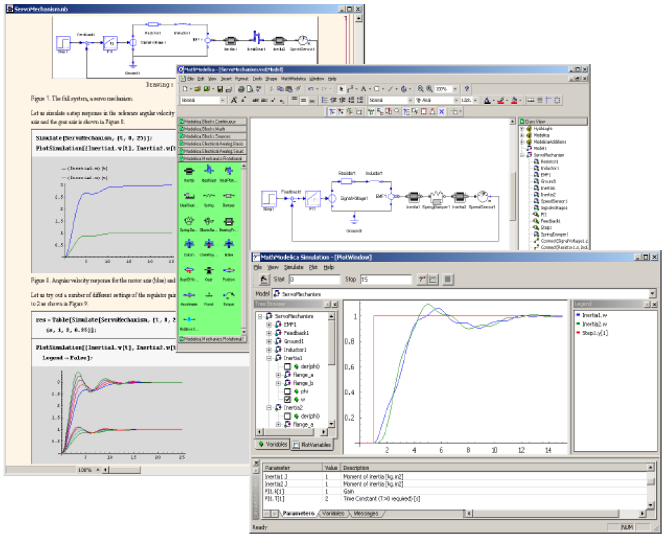
Figure X: The MathModelica Simulation Environment: Notebook, Model Editor and Simulation Center [X]

      - Dymola

Dymola is another modeling and simulation environment provided by Dynasim AB. Dymola screenshot is shown on figure X. Besides of graphical modeler and simulation capabilities it also contains interface to MathLab and SIMULINK, real-time 3D animation and CAD file import functionality. Users of Dymola are able to create their own libraries or modify the existing ones. Dymola has a very powerful Modelica translator which is able to work on models with huge number of equations (> 100 000).

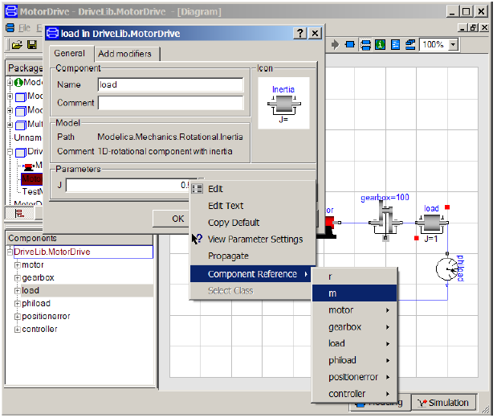

Figure X: The Dymola Modeling and Simulation Environment [X]

      - OpenModelica Tools

OpenModelica[X] is a project conducted by Programming Environment Laboratory (PELAB) at Linköping University. The main goal of the project is to create a complete Modelica modeling, compilation and simulation environment based on open source software. The architecture of OpenModelica environment is shown on figure [X].
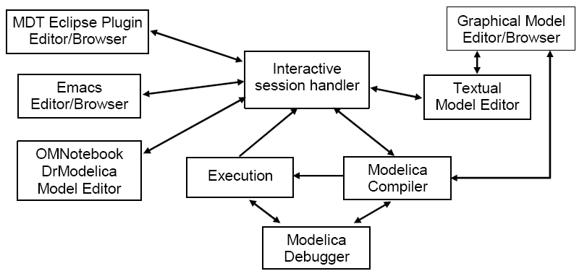
Figure X: The architecture of OpenModelica environment

OpenModelica has the following components [x]:
- Interactive session handler - parses and interprets commands and Modelica expressions sent to it by other components for evaluation, simulation, plotting, etc.
- OpenModelica Compiler (OMC) - translates Modelica to C code. OMC also builds simulation executables which are linked with selected ODE and DAE solvers.
- An execution and run-time module – executes compiled binary code as well as simulation code from equation based models, linked with numerical solvers.
- Emacs textual model editor/browser - model editor based on Gnu Emacs. Besides editor, browsing of Modelica file hierarchy is possible.
- Eclipse Plug-in editor/browser - Eclipse plugin which provides class and library hierarchy browsing, syntax highlighting and editing capabilities.
- OMNotebook model editor - similar to Mathematica Notebook editor with basic functionality which help document and perform simulation.
- Graphical model editor/browser - represents MathModelica Lite product provided by MathCore without cost for academic usage. Allows graphical model composition, Modelica library browsing, etc.
- Modelica debugger is a conventional full-feature debugger which uses Emacs as an interface for displaying the source code. Stepping, breakpoint setting/unsetting are supported.

  - UML and SysML

    - UML

Graphical modeling is an essential part of any medium to large software or system construction project. With a help of graphical models architects are able to specify high-level specification of a designed product, by specifying its architecture, structure and behavior. Since models allow working at a higher level of abstraction, they mask implementation of complicated details. Modeling helps focusing on different aspects of a system being designed, greatly improve communication between customers, business analysts, architects, testers, programmers, etc. Models have it full power if a graphical language they are presented in is commonly understood.

The most widely-used modeling standard in “software world” is UML, the specification of Object Management Group (OMG) [X]. UML helps specify, visualize and document design of software and non-software systems. The latest standard is UML2.0 which defines thirteen types of diagrams, divided into three categories: Structure, Behavior and Interaction diagrams.
Structure Diagrams include the Class Diagram, Object Diagram, Component Diagram, Composite Structure Diagram, Package Diagram and Deployment Diagram.
Behavior Diagrams include the Use Case Diagram, Activity Diagram and State Machine Diagram.
Interaction Diagrams, derived Behavior Diagram, include the Sequence Diagram, Communication Diagram, Timing Diagram, and Interaction Overview Diagram.

    - SysML
System Modeling Language (SysML) [x] is a modeling language for systems engineering applications developed and submitted by systems engineering experts, and adopted by OMG in May 2006. SysML is built on top of UML2.0 and tailored to the needs of system engineers by supporting specification, analysis, design, verification and validation of broad range of systems and system-of-systems. The main goal behind SysML is to unify and replace different document-centric approaches in system engineering field with a single systems modeling language. Single model-centric approach improves communication, assists to manage complex system design and allows its early validation and verification.

The taxonomy of SysML diagrams is presented on figure X. The following major extensions made in SysML:
- New type of a diagram to capture system requirements added to SysML. Requirements diagram supports requirements presentation in tabular or in graphical notation, allows composition of requirements and supports traceability, verification and “fulfillment of requirements”.
- Block diagram extends Composite Structure diagram of UML2.0. The purpose of this diagram is to capture system components, their parts and connections between parts. Connections are handled by means of ports which may contain data, material of energy flows.
- Parametric diagram helps perform engineering analysis such as performance analysis. Parametric diagram contains constraint elements, which define mathematical equation, linked to properties of model elements.
- Activity diagram shows system behavior as data and control flows. Activity diagram is similar to Extended Functional Flow Block diagram (EFFBDs), which is already widely used by system engineers. Activity decomposition is supported.
- Allocations are used to make mappings between model elements.
For example, a certain Activity and may be allocated to a Block, which implies that Activity will be performed by a block.

For a full description of SysML refer to (SysML, 2006) [x].

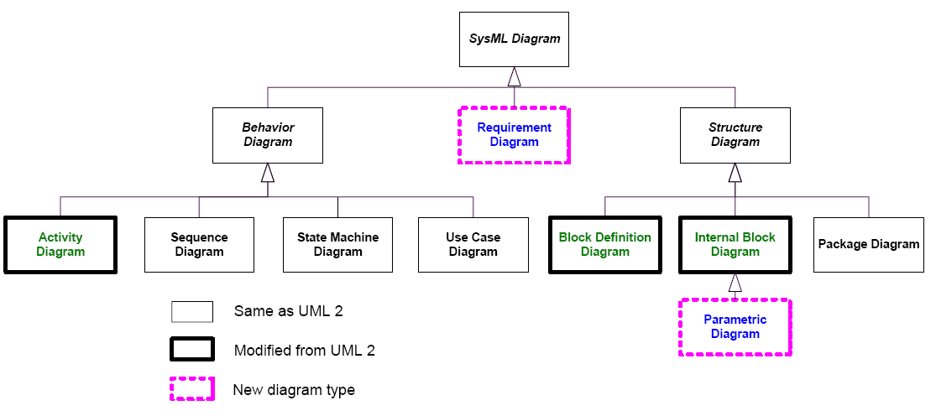
Figure X: SysML diagram taxonomy

  - Eclipse

“Eclipse is an open source community whose projects are focused on providing a vendor-neutral open development platform and application frameworks for building software “[X]. The Eclipse Foundation, consortium of more than 80 companies, is a non-profit organization which stands behind Eclipse to develop, support and promote an Eclipse Platform. All technology and source code in the Eclipse Platform is available through Eclipse Public License (EPL). There are ten top level projects being run on eclipse.org and each of a project is divided into several sub-projects.

    - Introduction to Eclipse Platform

The Eclipse Platform is a universal platform for development tools integration, which has an open and extensible architecture based on plug-ins. A plug-in could be regarded as a smallest unit of Eclipse function. Variety of tools could be build on top of Eclipse Platform by leveraging its plug-in based architecture and frameworks. The high-level architecture of Eclipse Platform is shown on figure X. Java Development Tools (JDT) is Java Development Environment implemented as Eclipse plug-ins and provides Java code browsing, editing, refactoring, compilation and debugging facilities. Plug-in Development Environment (PDE) is a set of tools for Eclipse plug-in development which is built on the top of Eclipse Platform and JDT.

Below the key advantages of using Eclipse Platform for tool development are presented:
- Clear and consistent architecture with standardized component model
- Multi-platform support (Windows, Mac OS, Linux, Solaris, etc.)
- Platforms native look and feel
- Text processing capabilities, like editors, content completion, formatting, searching
- Graphical modeling capabilities available through frameworks
- Configuration and preferences support
- Integrated update mechanism
- Integrated assistance and help system
- Internalization support
- Platform specific features (i.e. ActiveX) and legacy software integration support
- Backed by respected companies
- Based on open source model
- Wide community

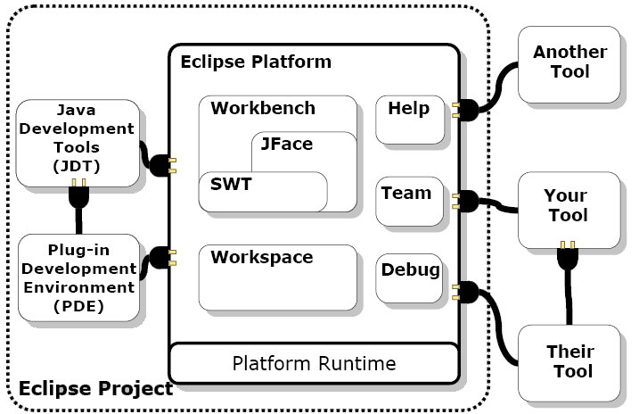

Figure X: Eclipse Platform architecture

    - EMF: Eclipse Modeling Framework

Eclipse Modeling Framework (EMF) [X] is an Eclipse based Java framework for building domain-specific model implementations. EMF implementation is based on “Object Management Group” (OMG) Meta Object Facility (MOF) standard. Particularly it implements “Essential MOF” (EMOF) part of a standard. EMF was also a significant contributor to this specification.

EMF is used in the following way. First, model specification should be provided. Second, Java code for a model is generated. After that, model may be refined and code regenerated or customized. In order to create EMF based model called “Ecore”, model description should be specified manually or provided in one of the following forms: Java interfaces, XML Schema or UML Class diagram (e.g. Rational Rose .mdl file). Ecore model description is represented in XMI format which describes classes, attributes, relationships and constraints of domain-specific model. Once an EMF model is specified, it’s transformed to Domain Generator Model from which Java implementation classes are created. Below some features of generated model implementation and EMF runtime are shown:
- Model change notification
- Model persistence and serialization (default is XMI, but can be overridden)
- Model Validation
- Dynamic object access through a Reflection API
- Integration with a rich user interface

EMF is used by several other frameworks within Eclipse projects. Particularly, two Eclipse frameworks GMF and UML2 which are described next are based on EMF.

    - GEF Graphical Editing Framework

Graphical Editing Framework (GEF) is an Eclipse framework for building graphical editors. GEF has a Model-View-Controller architecture that makes it flexible to integrate with a particular model. Major features of GEF are presented below[X]:

- Efficient layout and rendering support
- Various figures, layout and borders implementations
- Cursors and Tooltip support
- Connection anchoring, routing and decorating
- Flexible coordinate systems
- Printing support
- Tool Palette
- Tools like Selection, Creation, Connection and Marquee
- Object move ,resize , create, bend, connect
- Undo, redo, delete, direct-edit support
- Overview and zooming

    - GMF: Graphical Modeling Framework

“Graphical Modeling Framework (GMF) provides a generative component and runtime infrastructure for developing graphical editors based on EMF and GEF”[X]. GMF overview is shown on figure [x] and consists of tooling, generative and runtime parts. GMF depends on EMF and GEF frameworks and also on other EMF related tools, like EMF-Transactions, EMF-Validation and EMF-OCL.

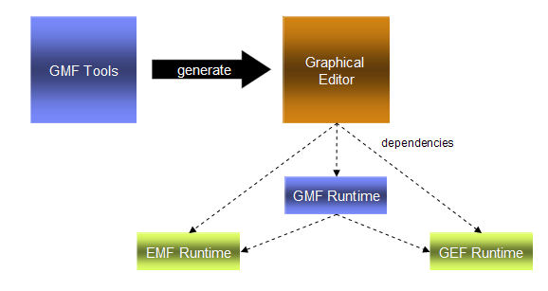
Figure X: GMF overview

In order to build a GMF based graphical editor, several input models should be provided first. The following input models are required: Graphical Definition, Tooling Definition, Mapping Definition and Domain Model. The result of transformation from input models is a Generation Model which specifies code generation related properties. The Generation Model is an input model to generative part of GMF.
- Domain Model represents an EMF based domain model implementation for a graphical editor.
- Graphical Definition contains description of graphical element like figures, nodes, connections, compartments and labels. Each element contains set of particular properties like layout, font, border, etc.
- Tooling Definition is used to describe Tool Palette entries, Menus and Actions.
- Mapping Definition captures relationships between domain elements, graphical elements and tooling. Mapping Definition model is a source of transformation to Generation Model.
Model transformation process graphically is described by figure [x].
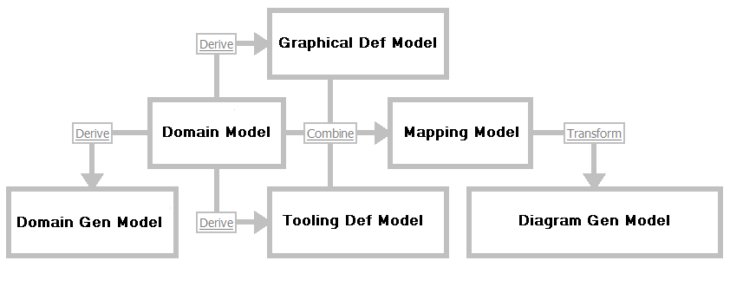
Figure X: GMF model transformation process

As a result of Java code generation we get most of GEF work done and lots of diagramming tasks already solved. After that, code modification and extension is required to get a graphical editor that fulfills all requirements. GMF also as EMF leverages Java Emitters Technology (JET) framework to manage and run code generation. JET provides a templating mechanism and several code generating features like Merge. With a help of JET, GMF model could be changed, to some extent, and code regenerated with a loss of modified parts of a code.

    - UML2: Eclipse UML2 meta-model implementation

The UML2 Eclipse project [X] is an EMF based implementation of UML2 meta-model for the Eclipse Platform to support development of UML modeling tools. UML2 project doesn’t aim to provide any graphical modeling or diagram interchange capabilities as it only implements UML abstract syntax.

- ModelicaML: a UML profile for Modelica

This section lists all major requirements to ModelicaML profile that should be supported. Because of the limited scope of this report we provide only top-level requirements, which are presented below.

- ModelicaML profile should support modeling of Modelica constructs and properties like restricted class, generics, discrete variables, etc.
- ModelicaML diagrams should be able to describe all aspects of a system being designed and support system development process phases like requirements analysis, design, implementation, verification, validation and integration.
- ModelicaML should be based on SysML, reuse and extend its elements
- The profile should support equations modeling since they describe behavior of a system in Modelica.
- Simulation related diagrams should be introduced that will document simulation parameters and results in consistent and usable way.
- XMI interchange capability should be supported.
- ModelicaML meta-model should be consistent with SysML to provide SysML-to-ModelicaML conversion.

  - ModelicaML diagrams

ModelicaML reuses several diagrams types from SysML without any extension, extends some of them and also provides several new ones. The ModelicaML diagrams overview is shown on Fig X. Diagrams are grouped by four categories like Structure, Behavior, Simulation and Requirement. The detailed description of diagrams is presented in the next sections.

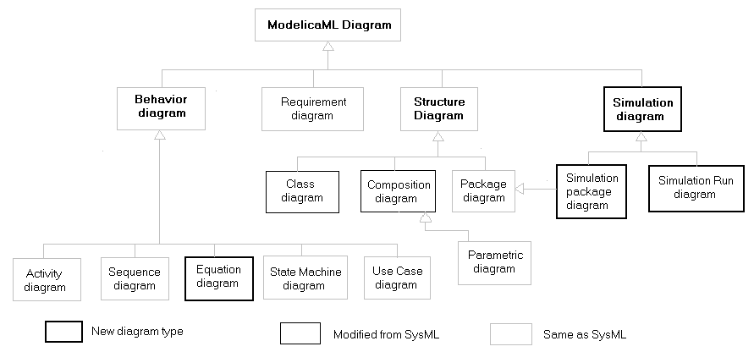
Figure X: ModelicaML diagram overview

    - Structure

This section provides a description of diagrams that describe static and internal structural aspects of a system.

Class Diagram is an extended Block Definition Diagram defined by SysML, which in its own extends UML2 Class Diagram. Since the main static construct in Modelica is a “class”, called a “block” in SysML, we renamed this diagram type to be more compatible with Modelica. Class Diagram usually includes class definitions and their relationships.

Composition Diagram extends Internal Block Diagram defined in SysML and describes internal class structure and interconnections between parts.

Package Diagram is reused from SysML. Package Diagram groups logically connected user defined elements into “packages”. In ModelicaML primarily purpose of this diagram will be Modelica Package modeling.

SysML defines Parametric Diagram to model a network of constraints, presented as equations, on system properties to support performance, reliability and mass property analysis. Since Modelica mostly is based on equations, this type of diagram could be used not only for analysis shown above but also to show how class properties correlate with equation parameters.

      - Modelica Class Diagram

Modelica Class and all restricted classes like Model, Block, Connector, Function and Record are the main constructs which describe a system in Modelica. Modelica Classes have the same semantic as SysML blocks as specified in [X] and provide a general-purpose capability to model systems as trees of modular components. ModelicaML extends SysML blocks by defining features which are relevant or unique to Modelica. The purpose of Modelica Class Diagram is to show features of Modelica classes and relationships between classes. Different kind of dependencies and associations between model elements may also be shown on Modelica Class Diagram. For example, behavior description constructs – equations, may be associated with particular Modelica Classes. The detailed description of structural features of ModelicaML is provided below. First, SysML block definition is shown, then ModelicaML structural extensions are defined and finally ModelicaML Class Diagram example is presented.

        - SysML block definition

SysML block definitions are shown on figure X. SysML block can include properties to specify block parts, values and referenced to other blocks. A separate compartment is dedicated for each of these features. To describe a behavior of a block “Operations” compartment reused from UML and lists operations that describe certain behavior. SysML defines a special form of compartment for a constraint definition owned by a block. The use of “Constraint” compartment is optional. “Namespace” compartment may appear if nested block definitions exist for a block. “Structure” compartment may appear to show internal parts and connections between parts within a block definition.
SysML defines two types of ports: standard ports and flow ports. Standard ports, which are reused from UML, are service-oriented ports required or provided by a block. Flow ports specify interaction points through which items may flow between blocks, and between blocks and environment. Flow port definition may include single item specification or complex flow specification through FlowSpecification interface. Flow direction can be specified for a flow port in SysML. SysML defines a notion of Item flows that specify “what” does flow compare to what “can” flow specification of a flow port in a particular usage context.
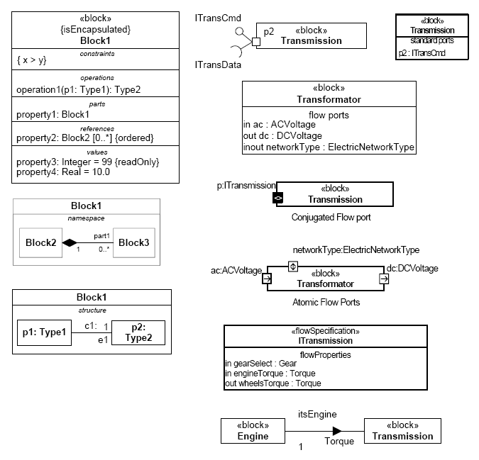
Figure X: SysML block definitions

        - ModelicaML class definition

Graphical notation of ModelicaML class definitions is shown on figure [x]. Each class definition is adorned with stereotype name that indicates the class type it represents. Modelica class definition has several compartments to group its features like parameters, parts, variables. Some of compartments are visible by default, some are optional and may be shown on Modelica Class Diagram with a help of ModelicaML tool. Property signatures follow descriptive Modelica syntax and not SysML original syntax, reused from UML. Using Modelica syntax on a diagram has an advantage of being more compatible with Modelica and being more understandable for Modelica users. Modelica syntax is quite simple to learn even for users not acquainted with Modelica. ModelicaML provides many extensions to SysML in order to support full set of Modelica constructs and features. Full definitions of these extensions are grouped and described below.

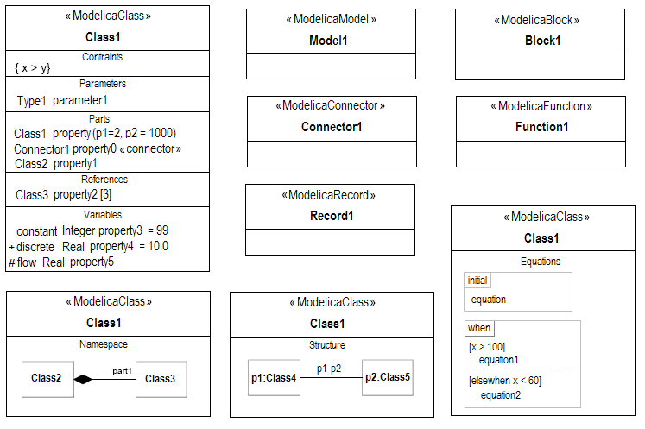
Figure X: ModelicaML class definitions

Class definition types

ModelicaML defines unique class definition types ModelicaClass, ModeliceModel, ModelicaBlock, ModelicaConnector, ModelicaFunction and ModelicaRecord that corresponds to Class, Model, Block, Connector, Function and Record Modelica restricted classes. Modelica type modeling is described separately in “Short Class and Type definition” paragraph.

Compartments

In order to be compatible with SysML ModelicaML reuses SysML compartments and defines several new ones. The only compartment which is not supported by ModelicaML is an Operations compartment. There are some restrictions on compartment visibility depending on a type of a restricted class. For example, ModelicaRecord can not contain an equations compartment. By default, Parameters, Parts and Variables compartments are visible on all Modelica class definitions. ModelicaML tool should be able to show and hide compartments on behalf of a user. The following are compartments supported by ModelicaML.

- Parameters compartment
Since Modelica parameters are essential elements of a class definition and bear an important semantic, there visibility on a diagram is improved by putting all parameters under a single compartment. Modelica parameters are typed by primitive types, enumerations, Modelica Records, built-in classes and subtypes of primitive types.
- Parts compartment
Parts compartment in ModelicaML has the same semantic as specified in SysML, to show components which constitute a block, in Modelica case a class.
Parts compartment list properties of Modelica class which are typed by other classes and not contain properties typed by enumerations, Modelica Records, built-in classes and subtypes of primitive types. A class part is not listed in Parts compartment if the part class definition is already presented on a diagram and associated with a containing class by part association relationship. For example, a class may be put on the diagram from Modelica library with all dependant part classes and their associations. In this case, Parts compartment of the class will be empty, since parts are already shown on the diagram. In an opposite case, when part classes are not shown on the diagram, parts compartment of the class will be filled.

- “Flow Ports” compartment
ModelicaML preserves “Flow Ports” compartment for compatibility purpose with SysML and introduces another way of showing ports, in Modelica language called connectors. Modelica Connector could be regarded as a part through which some items flow. Thus, putting Modelica Connector in a Parts compartment and hiding “Flow Ports” compartment will not break the semantics. In order to mark out connectors from other parts, it’s adorned with a special alias called “connector” in the Parts compartment (see figure [x]). Moreover, having to many compartments over a class may decrease the visibility of its elements.
ModelicaML tool may support both port representation styles and allow a user to choose the preferred one.

- References compartment
Modelica doesn’t support references directly. Usually on a diagram, references are backed by reference association relationship between components. ModelicaML preserves this compartment for two purposes. First, References compartment is required for compatibility with SysML. Another reason is that reference associations are used on definition diagram to show that some association exists between two components. See chapter 7.8 for details regarding reference association relationships.

During the detailed design phase, reference associations are usually transformed to connections between components. As in a Parts compartment case, References compartment may not contain elements which are already explicitly shown on a diagram.
- Variables compartment
Values compartment of SysML is renamed to Variables compartment in ModelicaML and lists variables of a Modelica class, including constant and discrete variables. Variables are only typed by primitive types, primitive type subtypes, built-in classes and enumerations.
- Constraint compartment
Constraint compartment is an optional compartment which is used to capture constraints for a Modelica class.
- Namespace compartment
Modelica class may contain nested class definitions which may be shown on Modelica Class diagram. There are two ways of showing nested definition in ModelicaML. One way is to use Namespace compartment of a class, another – to use a containment relationship between elements (see Nested classes paragraph below). A user of ModelicaML tools will decide upon a suitable way of presentation of nested definitions.

- Structure compartment
Structure compartment is used to show how internal parts are connected. This is an optional compartment since class structure is presented on a separate Modelica Composition Diagram (see section 3.3.1.2). A user of ModelicaML tool may decide to show or hide the structure of a class on Modelica Class Diagram depending on his design presentation intents.
- Equations compartment
Equations compartment may be shown on Modelica Class Diagram to depict the behavior of a class. There is a separate diagram type called an Equation Diagram for behavior modeling (see section 3.3.2.1).

Property definition

Property definition is not the same as in SysML since ModelicaML follows Modelica syntax conventions which results in the same look as in Modelica code, with some exceptions. Different cases with examples of property definitions are explored below. Full explanations of Modelica syntax can found in [x] and [x].

- name and type
Examples: ‘Real b ‘, ‘Inductor inductor1’

- initialization of variables
Examples: ‘Real mass (start=590)’,
‘CelistialBody moon (name=”moon”, mass=7.382e22)’

- default values:
Examples: ‘Real m = 0.27’, ‘constant Real g = 6.672e-11’,
‘Real c (unit=”N/m”) = 1’

- access property (visibility)
Modelica supports only ‘public’ and ‘protected’ access properties. By default ‘public’ is assumed. ModelicaML utilizes UML way of describing visibilities by using ‘+’ and ‘#’ signs. First for public properties and the second one for protected. Since access properties don’t provide much information for designer compare to other attributes of properties, use of UML style is sufficient for comprehension. Another advantage of UML style visibilities is that it saves some space in compartment.
Examples: ‘+ Real b‘, ‘# Inductor inductor1’

- array definition
Examples: ‘Real positionvector [3] = {1, 2, 3}’,
‘Real v1 [5] = 2.7: 6.8’

- causality prefixes: input and output
Examples: ‘input Real x’, ‘output Real y’

- variability prefixes
Modelica defines three variability prefixes: ‘constant’, ‘discrete’ and ‘parameter’. ModelicaML explicitly allows specification only for constants and discrete variables. Parameter specification is omitted since it’s implied by Parameters compartment.
Examples: ‘constant Integer i = 5’, ‘discrete Real b (start = 1)’

- flow prefix
Example: ‘flow Current i’

- instance hierarchy lookup prefixes
Examples: ‘inner Real T0’, ‘outer Real T0’
- modification prefixes
Modelica defines three modification prefixes: ‘replaceable’, ‘redeclare’ and ‘final’.
Example: ‘final Real r3 = cos (r2)’ (parameters compartment),
‘Real time (final quantity = “Time”, final unit = “s” ’

For other prefixes details see Generic Classes paragraph.

Partial classes

ModelicaML partial class is similar to abstract class definition of SysML/UML. Partial class notation variants are defined as:

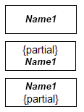

Figure X: Partial class graphical notation

        - Relationships

This section describes a graphical notation of relationships, defined by ModelicaML, which may exist between elements on a Modelica Class Diagram. For better comprehension, each type of described relationships is supported by an example.

Generalization

Generalization represents a class inheritiance relationship. Graphical notations of generalization are shown on figure x. Compare two SysML, definition details can be attached to a link (see example 2 below). There is a special stereotyped generalization, marked with “redeclare” stereotype, used for generic classes modeling. See “Generic classes” chapter for generic classes modeling description.

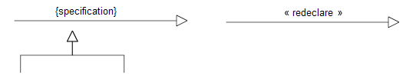
Figure X: Generalization graphical notation

Example 1:

partial Class TwoPin
Pin p, n;
Voltage v;
Current i;
equation
. . .
end TwoPin;

class Resistor extends TwoPin
parameter Real R(unit=”Ohm”);
equation
. . .
end Resistor;

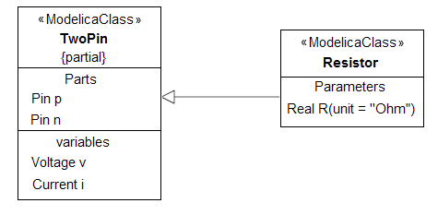
Figure X: Generalization example diagram 1

Example 2:

partial model BaseController
parameter Real K = 2;
parameter Real T(unit = “S”) = 10;
...
equation
...
end Base Controller;

model PIDcontinuousController
extends BaseController(K=2,T=10);
Real x;
Real y;
equation
...
end PIDcontinuousController;
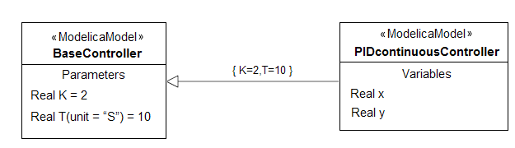
Figure X: Generalization example diagram 2

Part association

Part association, shown on figure x, describes whole-part relationships between components. It can be adorned with an optional association name, property name of part component and an optional definition specification. Property name may contain array definition (???) is case of multiple part aggregation. UML multiplicity elements, which simply show a possible range of values (for example 1..4 ), are not suitable for Modelica. There is a special stereotyped part association, marked with “replaceable”, used for generic class modeling (see chapter “Generic classes” for details).

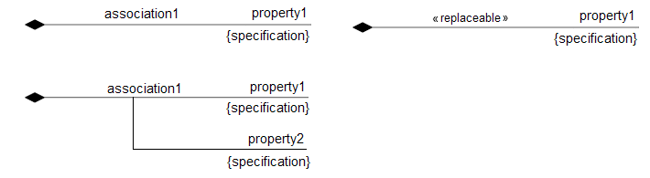
Figure X: Part association graphical notation

Example 1:

class SimpleCircuit
Resistor R1(R = 10);
Capacitor C(C = 0.01);
Resistor R2(R = 100);
Inductor L(L = 0.1);
VSourceAC AC;
Ground G;
end class;
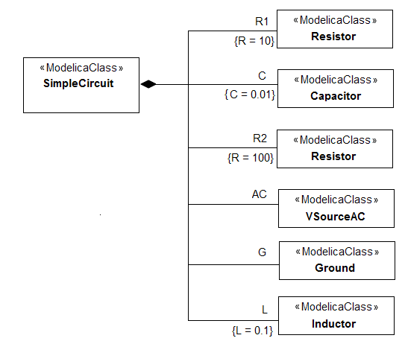
Figure X: Part association example diagram 1
Example 2:

model Component
. . .
end Component;

model TwoComponents
parameter Integer n;
Component Comp[n];
end TwoComponents;

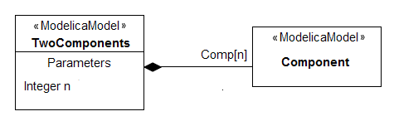
Figure X: Part association example diagram 2

Reference association

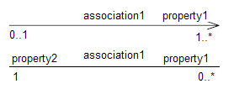
Figure X: Reference association graphical notation

Example:
TODO

Namespace containment

Namespace containment link, shown on figure x, is used to model nested definition of classes and types on Modelica Class Diagram. For examples see chapter “Nested definitions”.

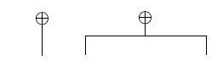
Figure X: Namespace containment graphical notation

Dependencies: package import

Package import relationship, represented as a dependency link with an “import” stereotype, shows imported packages of a class.
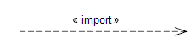
Figure X: Package import dependency graphical notation

Example 1:

model SampleModel
import Modelica.SIunits;

parameter SIunits.Length L = 10;
parameter SIunits.Velocity V = 1;
...
equation
...
end SampleModel;

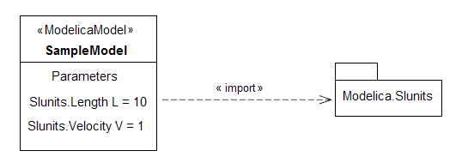
Figure X: Package import example diagram

Example 2:

model ComplexUser
import Modelica.Math.ComplexNumber.Complex;
import Modelica.Math.ComplexNumber.Add;

Complex a(x=1.0, y=2.0);
Complex b(x=1.0, y=2.0);
Complex c;
equation
c = Add(a, b);
end ComplexUser;

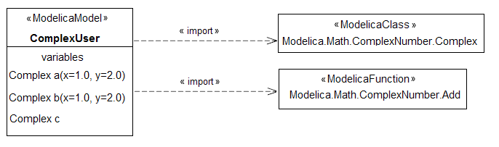
Figure X: Class import example diagram

Dependencies: function call

Function call relationships, represented as a dependency link with a “call” stereotype, may be used to model function calls of a class, as shown in example below.
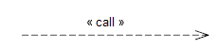
Figure X: Function call dependency graphical notation

Example 1:

function SampleFunction
parameter Integer incValue = 10;
input Real x;
output Real y;
algorithm
y = x + incValue;
end SampleFunction;

model SampleFunctionCallModel
Real x;
Real y;
equation
y = SampleFunction(x);
end SampleFunctionModel;

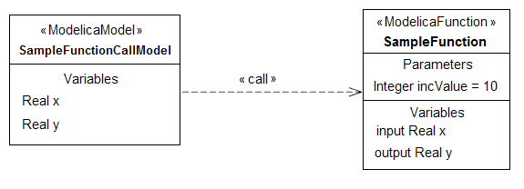
Figure X: Function call example diagram

Dependencies: supertype relationship

Modelica implicitly defines supertype/subtype relationship between classes, which are used in several cases like redeclarations, instance hierarchy lookup, etc. In order to make Modelica Class diagram more informative supertype relationship may help to model supertype/subtype relationships. Super type relationship notation is presented here:
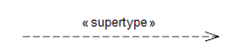
Figure X: Supertype dependency graphical notation

Example 1:

model Resistor
parameter Real R(unit=”Ohm”);
Pin p, n;
Voltage v;
Current i;
equation
v = i * R;
end Resistor;

model TempResistor
parameter Real R(unit=”Ohm”);
parameter Real RT(unit=”Ohm/degC”) = 0;
parameter Real Tref(unit=”degC”) = 20;
Pin p, n;
Voltage v;
Current i;
Real temp = 20;
equation
v = i *(R + RT*(Temp – Tref);
end TempResistor;
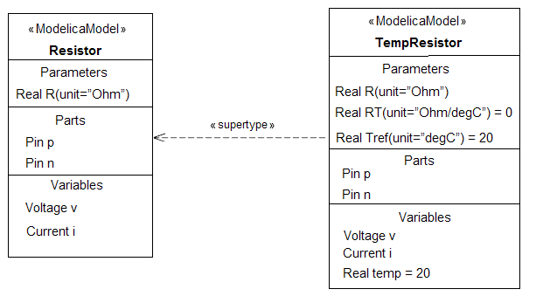
Figure X: Subtype/supertype relationship example diagram

Dependencies: general

With a help of modeling tool additional dependency relationships may be defined by as user. General notation of dependency relationship is depicted on figure x.
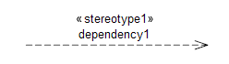
Figure X: User defined dependency graphical notation

        - Short class and type definition

Modelica allows user to declare type definitions based on primitive types, arrays of primitive types, enumerations and records. For example:

Example 1:

Type Voltage = Real (unit = “V”, min = -220.0, max = 220);

Another way to extend primitive types and enumerations is to use short class definition syntax. The same type definition as a short class looks like:

Example 2:

Class Voltage = Real (unit = “V”, min = -220.0, max = 220);

Type definitions and short classes have the same semantics, with the same set of restrictions. For example, variable and equations cannot be added to derived type/class and attributes cannot be redeclared. Only the value attribute can be changed at run-time.

SysML defines ValueType stereotype for type definitions. ValueType has two properties to describe a type, ‘dimension’ and ‘unit’, which are similar to properties of Modelica Real type. Since Modelica primitive types are more reach in terms of properties, ModelicaML redefines SysML ValueType stereotype with its own notation. There are four predefined stereotypes in ModelicaML that correspond to Modelica Real, Integer, Boolean and String types. See chapter 3.4 for details of ModelicaML type meta-model.

ModelicaML follows a convention of profile extensibility of SysML/UML and defines short class and type definitions in the following way, which applies to the examples 1 and 2 above:

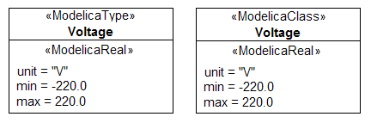
Figure X: Type definition example 1 and 2

Other examples of type definitions:

Example 3:

Type Matrix = Real[3,3];

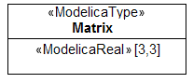
Figure X: Type definition example 3

Example 4:

Type Length = Real (final quantity=”Length”, final unit=”m”);

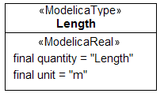
Figure X: Type definition example 4

Example 5:

Type PathLength = Length;

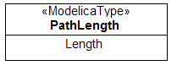
Figure X: Type definition example 5
Example 6:
connector RealInput = input Real;

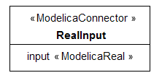
Figure X: Type definition example 6

There is another way of short class and type definition modeling based on inheritance which is described in “Relationships” paragraph of this section.

Enumerations

Enumeration definition is similar to other type definitions described in “Short class and type definition” section. Sample graphical notation of enumeration type is shown next.
Example:

Type AllSizes = enumeration (small, medium, large, xlarge);

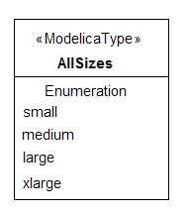
Figure X: Enumeration type definition example

Local class definitions

Modelica allows definitions of new classes and types, called local class definitions, within a namespace of another class. An example of local class definition case is shown in this section together with corresponding ModelicaML diagram.
class C1
class Lpin
Real p;
End Lpin;

class Voltage = Real(unit=”kV”);

Lpin pn;
Voltage v;
end C1;

There are two ways to model a local class definition in ModelicaML. In the first one, Namespace compartment is used as a container of local class definitions. In the second way, namespace containment relationship is used as an alternative. Figures x depicts both cases.
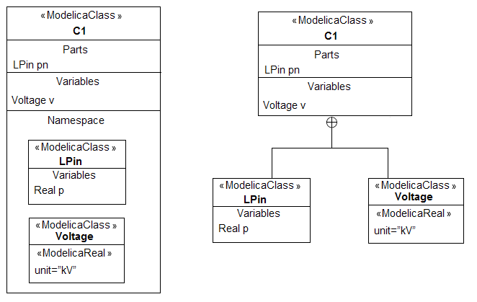
Figure X: Local class definitions

        - Generic classes

Modelica supports generic constructs for class parameterization which greatly enhance components reusability. ModelicaML fully supports modeling of all class parameterization cases which will be discussed later in this section. There are mainly two ways of generic class parameterization in Modelica (for details see chapter 4 of [X]):
  - Instance formal parameters, for which variable declarations are supplied as actual arguments
  - Type formal parameters, for which classes are supplied as actual arguments
For better comprehension, examples of detailed parameterization cases and their corresponding ModelicaML counterparts are shown together.

Parameters being components:

This is the case where class parameters represent instances of a particular class and are marked by the ‘replaceable’ keyword. Such parameterization makes it possible to redeclare the instances with other provided instances (see TemperatureResistorCircuit class below). A newly provided class should be a subtype of a replaceable class or a class which is directly specified in declaration (i.e. TwoPin in GenericResistorCircuit model). Full information about subtyping can be found in [x] and [x].

model GenericResistorCircuit
replaceable Resistor R1(R = 100);
replaceable Resistor R2(R = 200);
replaceable Resistor R3(R = 300) extends TwoPin;
equation
connect(R1.p,R2.p);
connect(R1.p,R3.p);
end GenericResistorCircuit;

Figure x shows one way of modeling for the current case, where a replaceable part is shown within a Parts compartment. Another way, using replaceable part association, is shown on the figure x. Replaceable part association is marked with “replaceable” stereotype and besides the name of a redeclared instance may contain initialization specification, as shown on figure x.

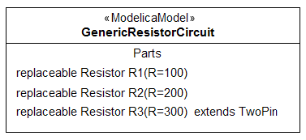
Figure X: Parameters being components (modeling within a compartment)

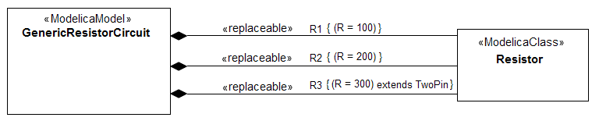
Figure X: Parameters being components (modeling using part association)

Declaration of a new model which provides new instances as replacement of original ones may be done using short class definition syntax, as shown below. ModelicaML model counterpart for this example is presented on the figure x next.

model TemperatureResistorCircuit =
GenericResistorCircuit (redeclare TempResistor R1,
redeclare TempResistor R2,
redeclare Capacitor R3(C=0.003) );

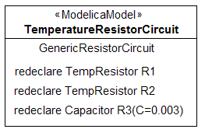
Figure X: Parameters being components (redeclaration as type definition)

Besides type definition way of redeclaration, standard class syntax may be used for class parameterization (TemperatureResistorCircuit model below). In this case, a new definition extends the original one. Corresponding ModelicaML models for this example are shown on Figure x and x. One way to model extended parameterization is to use “redeclare” generalization with some additional specification (figure x) and another by attaching ModelicaSpecification note box to generalization link with full specification details (figure x) or by providing definition as a relationship specification (see Generalization section examples).

model TemperatureResistorCircuit
Real Temp;
extends GenericResistorCircuit(
redeclare TempResistor R1,
redeclare TempResistor R2,
redeclare Capacitor comp1(C=0.003));
end model;

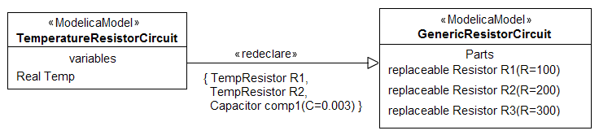
Figure X: Parameters being components (redeclaration using “redeclare” generalization)

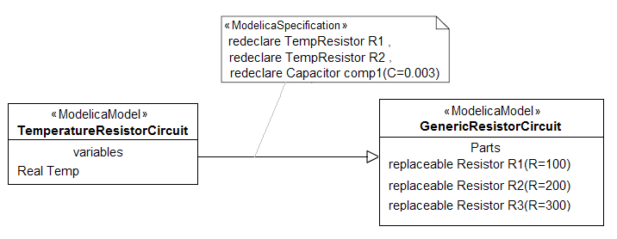
Figure X: Parameters being components (redeclaration using generalization with ModelicaSpecification)

Class parameters being types:

Modelica type parameterization mechanism can be used to change the type of many objects of a class. For example, GenericResistorCircuit2 model below defines replaceable type called ResistorModel, which is based on another class (Resistor in this case), and is used to declare several part variables (R1, R2 and R3). With a help of type parameterization, default ResistorModel type can be replaced with a new one in a specialized model (see RefinedResistorCircuit2 model example).

model GenericResistorCircuit2
replaceable model ResistorModel = Resistor;
ResistorModel R1(R = 100);
ResistorModel R2(R = 200);
ResistorModel R3(R = 300);
equation
connect(R1.p,R2.p);
connect(R1.p,R3.p);
end GenericResistorCircuit2;

Type parameterization can be viewed as a special case of type definition, which is explained in “Short Class and Type definition” section. In case of type parameterization new type definition is always a class internal construct and is marked with “replaceable” keyword. Thus, nested classes modeling, as described in “Nested classes” section, can be applied to type parameterization.
Figure x below depicts both cases of modeling of a nested constructs in context of type parameterization.

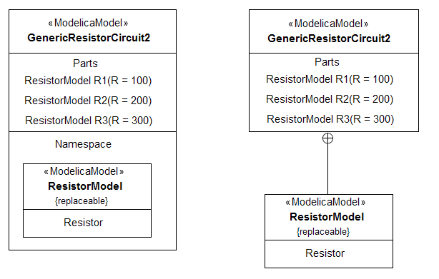
Figure X: Type parameterization modeling

Specialized model definition, which replaces a type with a new one, may be done using short class definition syntax as shown here:

model RefinedResistorCircuit2 = GenericResistorCircuit2
(redeclare model ResistorModel = TempResistor);

Corresponding ModelicaML representation for this example looks like:

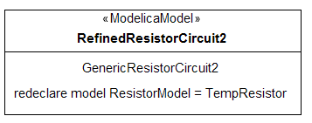
Figure X: Class type redeclaration

Parameterization and extension of interfaces:

Type parameterization can be used for parameterization and extension of connectors. The next example contains declaration of replaceable connector type TankStream. There are two connectors declared, inlet and outlet, which are of the type TankStream. By a specialized version of the Tank model (HeatTank model) the replaceable connector type is replaced with a new connector type HeatStream.

model Tank
parameter Real Area = 1;
replaceable connector TankStream = Stream;

TankStream inlet, outlet;
Real level;
equation
. . .
end Tank;

connector Stream
Real pressure;
flow Real volumeFlowRate;
end Stream;

model HeatTank extends
Tank(redeclare connector TankStream = HeatStream);
Real temp;
equation
. . .
end HeatTank;

connector HeatStream extends Stream
Real temp;
end HeatStream;

Figure x is a ModelicaML model for presented example which shows how to model connector type parameterization case. Generalization link marked with “redeclare” stereotype can be replaced with an ordinary generalization link with ModelicaSpecification box fill with extension details like in figure x.

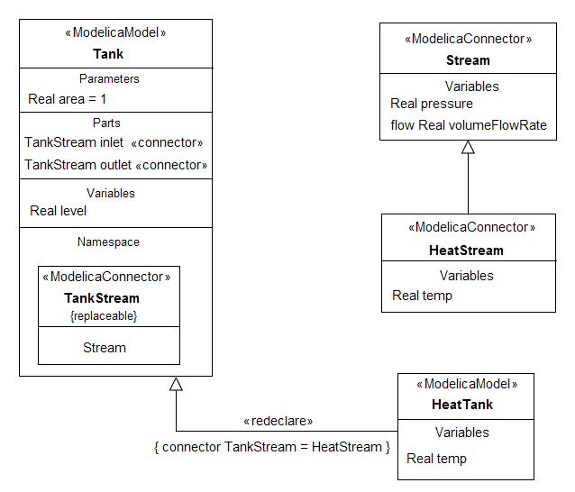
Figure X: Parameterization and extension of interfaces

Extending and redefining behavior:

One of the ways to redefine behavior of a class is to use a nested replaceable class which contains behavior to be redefined or extended. Modelica example below and its ModelicaML representation show how to model such a case.

model Resistor3
Pin p, n;
Parameter Real R(unit = “Ohm”);

replaceable class ResistorEquation
Voltage v;
Current i;
equation
v = i*R;
end ResistorEquation;
extends ResistorEquation;
end Resistor3;

model TempResistor3
extends Resistor3 (redeclare class ResistorEquation
Voltage v;
Current I;
equation
v = i*(R + RT * (Temp – Tref));
end ResistorEquation;

parameter Real RT(unit = “Ohm/degC”)=0;
parameter Real Tref(unit = “degC”)=20;
Real temp = 20;
end TempResistor3;

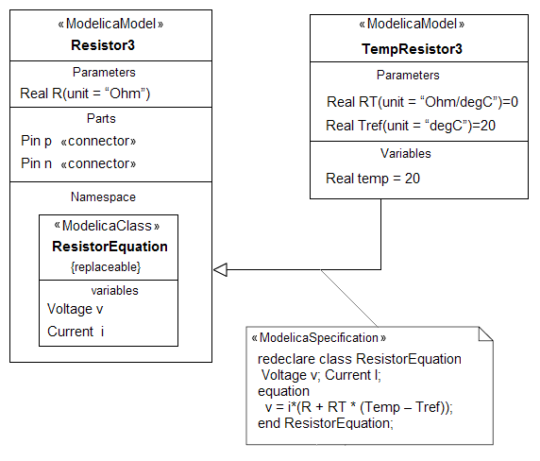
Figure X: Extending and redefining behavior

        - Annotations

An annotation is a property containing information associated with some element of a Modelica model. With a help of annotations, model can be documented, graphical icons defined, version specified, etc. ModelicaML doesn’t specify way of a presenting annotation on a diagram, but provides attributes to save annotation information within a model. With a help of a modeling tool, designer should able to set annotations for a different model elements. The modeling tool may implement some visual ways of displaying annotations in interactive way, for example by means of tool tips. Generated model documentation, generated by a modeling tool, may also incorporate annotations in some form.

        - Other Modelica Class Diagram elements

Several other model elements, not described in the chapters above, may be shown on a Modelica Class Diagram. Most of such constructs are reused from SysML[x]. Below is the list of some of them:
- Comment, Rationale, Problem, View and Viewpoint
- Actor
- Crosscutting constructs, like Requirements and Allocations
- Equation blocks associated with classes (see chapter “Equation diagram” for examples)
- Simulation packages associated with classes (see chapter “Simulation Package diagram” for examples)

        - Not supported SysML constructs

ModelicaML doesn’t support the following SysML block definition constructs:
- Operations definition on block and type constructs
- DataType and ValueType elements are replaced with a ModelicaType
- Shared association
- Generalization sets
- Standard ports
- Conjugated ports
- Interface element
- FlowSpecification ( Connector classes replace it)
- Item Flow

      - Package Diagram

A UML Package is a general purpose model element for grouping other elements. With a help of packages, designers are able group elements to correspond to different structures/views of a system. ModelicaML extends SysML packages in order to support Modelica packaging features, in particular: package inheritance, generic packages, constant declaration within a package, package “instantiation” and renaming import (see [x] for Modelica packages details). A diagram which contains package elements and their relationships is called a Package Diagram. The subsequent sections of this chapter describe Package diagram elements, supported by examples.

        - Package element graphical notation

A figure x below shows different layouts of graphical package representation. It’s up to designer to choose the preferred layout for a package and its content visualization for a certain package diagram (there may by several package diagrams for the same model). Basically, there are three such layouts: closed box, open box and list layout. ModelicaML defines a Constants compartment for a list layout in order to support constants declarations within a package. The main compartment of the list layout shows member elements, adorned with class type stereotype and an option visibility sign.
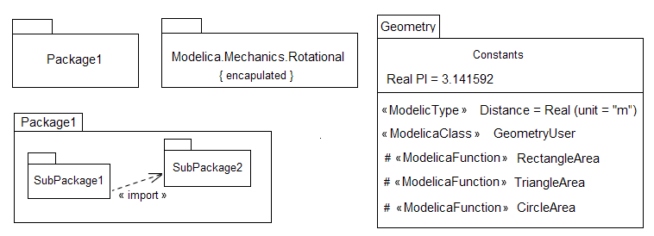
Figure X: Package graphical notation
        - Package hierarchy

Modelica packages have hierarchical structure containing a package element as a node. In Modelica, packages are used to structure model elements into libraries. A snapshot of Modelica standard library hierarchy is shown on figure x using UML notation. Package nodes in the hierarchy are connected view package containment link.
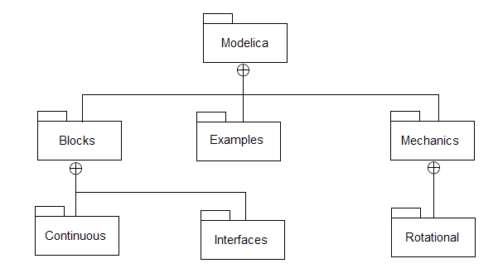
Figure X: Package hierarchy modeling

        - Package member classes and types

Package member classes and types can be shown on a Package or a Class Diagram. One way of member class presentation, as a list layout, was already depicted on figure x above. Other two styles are introduced below and based on the following example.

Example 1:
package GeneralStack

replaceable class Element
end Element;

record Stack
parameter Integer maxSize = 0;
Integer size = 0;
Elementp[maxsize] = vec;
end Stack;

function Push
...
end Push;

function Pop
...
end Pop;

function Top
...
end Top;
end GeneralStack;
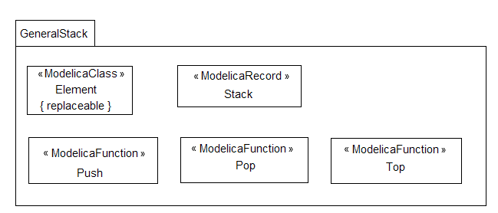
Figure X: Package elements as nested boxes
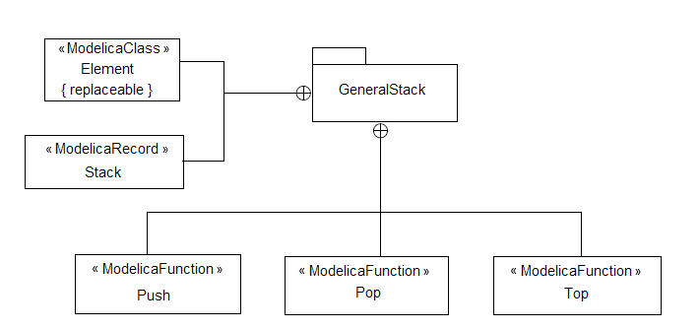
Figure X: Package elements as external boxes
        - Package import

Modelica defines several package import methods: qualified and unqualified, renamed and single definition import. UML modeling of a single definition import of a class is described in section x. UML representation of others is shown below. For details about Modelica package import see chapter 10 of [x].
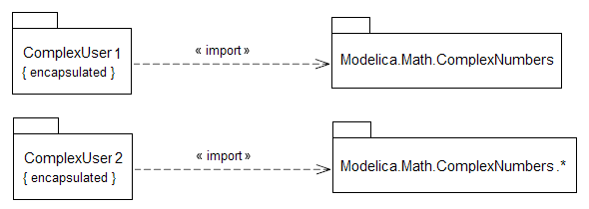
Figure X: Qualified and unqualified package import

Renaming import example and corresponding ModelicaML model are shown here.
Example 1:
class ComplexUser3
Import Co = Modelica.Math.ComplexNumbers;
Co.Complex a(x = 1.0, y = 2.0);
Co.Complex b(x = 1.0, y = 2.0);
Co.Complex z,w;
equation
. . .
end ComplexUser3;

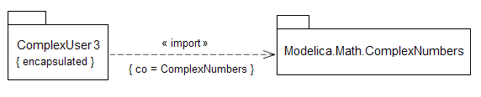
Figure X: Renaming package import

        - Generic packages and inheritance
Example 1:
package DoubleEndedQueue
extends GeneralStack;
function AddBottom
...
end AddBottom;
function RemoveBottom
...
end RemoveBottom;
function Bottom
...
end Bottom;
end DoubleEndedQueue;

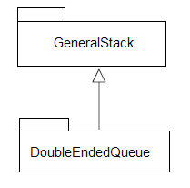
Figure X: Package inheritiance

Example 2:
package IntegerStack = GeneralStack(redeclare type Element = Integer);

package RealStack = GeneralStack(redeclare type Element = Real);

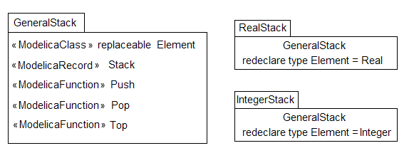
Figure X: Generic Package example 1

Example 3:
package PowerTrain

replaceable package GearBoxes
...
end GearBoxes;

end PowerTrain;

package MyPowerTrain
extends PowerTrain; // use all classes from PowerTrain

package extends GearBoxes // add classes to sub-library
...
end GearBoxes;

end MyPowerTrain;

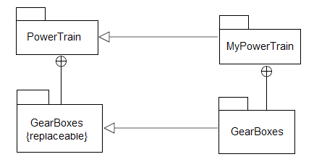
Figure X: Generic Package example 2

Example 3:
partial package PartialMedium
constant Integer nX;

replaceable partial model BaseProperties
...
end BaseProperties;

replaceable partial function DynamicViscosity
...
end dynamicViscosity;

end PartialMedium;

package Air extends PartialMedium(nX = 1);

model extends BaseProperties (
(T (stateSelect = StateSelect.prefer));

redeclare function DynamicViscosity
... // replaces by a new implementation
end dynamicViscosity;

end Air;

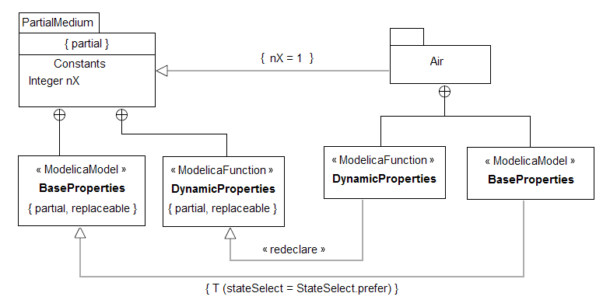
Figure X: Generic Package example 3

      - Modelica Composition Diagram
TODO: full description

      - Parametric Diagram
TODO: short description

    - Behavior

      - Equation Diagram
TODO: full description

      - Activity Diagram
TODO: short description

      - State Machine Diagram
TODO: short description

      - Sequence Diagram
TODO: short description

      - Use Case Diagram
TODO: short description

    - Simulation

      - Simulation Package Diagram
TODO: full description

      - Simulation Run Diagram
TODO: full description

    - Requirements

      - Requirements Diagram
TODO: short description

  - ModelicaML meta-model description
TODO

- Modelica Open Studio: an integrated system specification, development and simulation environment
TODO
  - Vision
  - Architecture

- Implementation of ModelicaML Class and ModelicaML Internal Class diagrams
TODO
  - Implementation of ModelicaML Class diagram
    - Overview
    - GMF model
    - Package structure
    - Implementation cases

  - Implementation of ModelicaML Internal Class diagram
    - Overview
    - GMF model
    - Package structure
    - Implementation cases

- Conclusion and Future Work
TODO
  - Conclusion
  - Future work

- References
List of figures
Glossary
Appendix A: Package description

